Student AccessND Training
Supplemental Accommodation Request

- In InsideND, Search “AccessND” and click on the logo to navigate to your Student page.

- You will then see your Student Home Page.
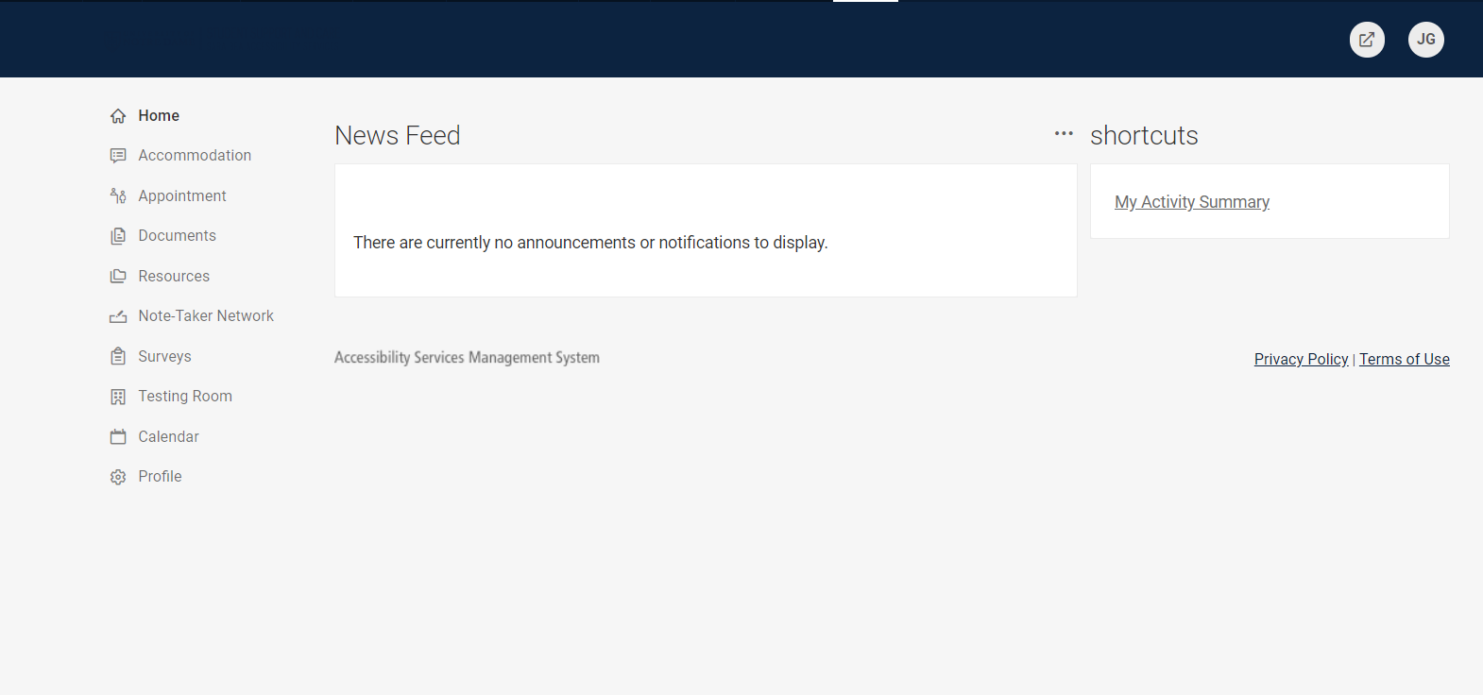

- Click on Accommodation and then choose Supplemental from the options below it.
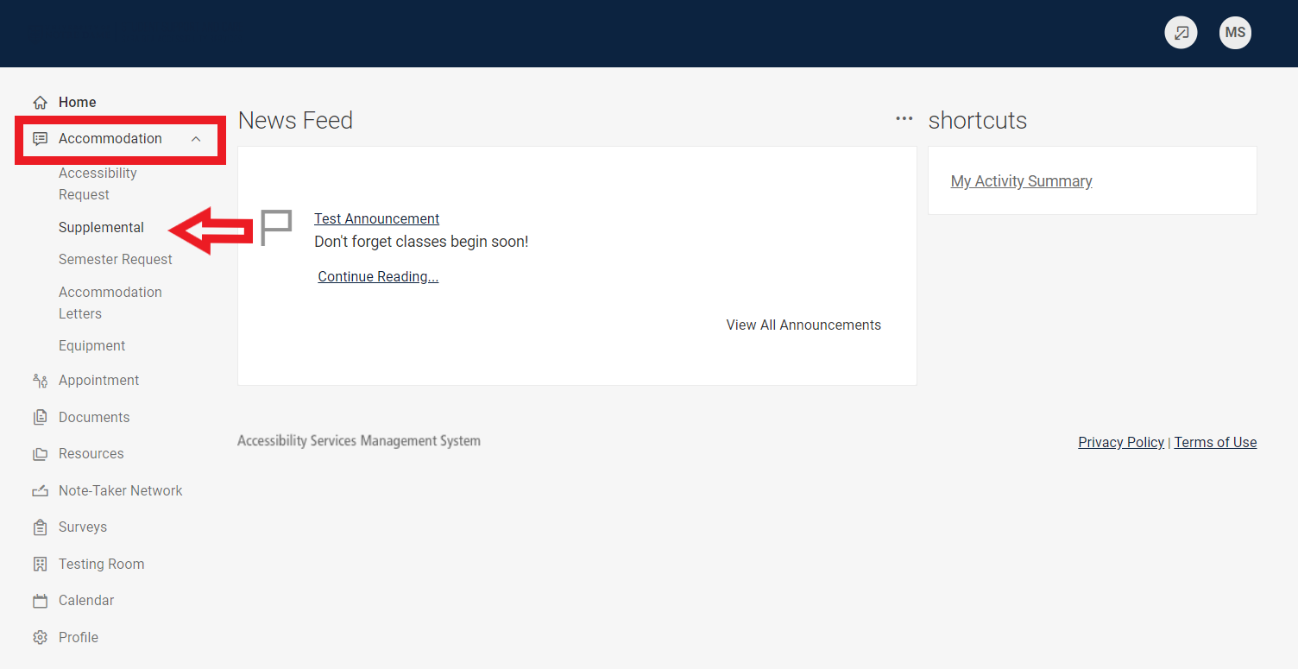

- Click Add New
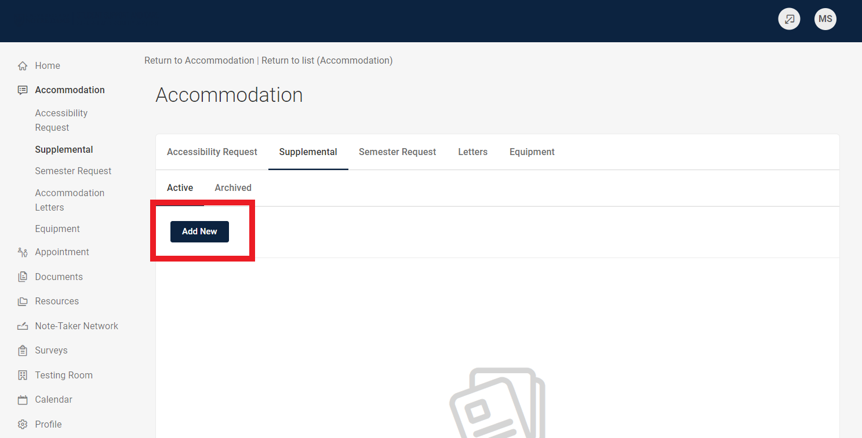

- If the request is not related to Covid-19, click No.
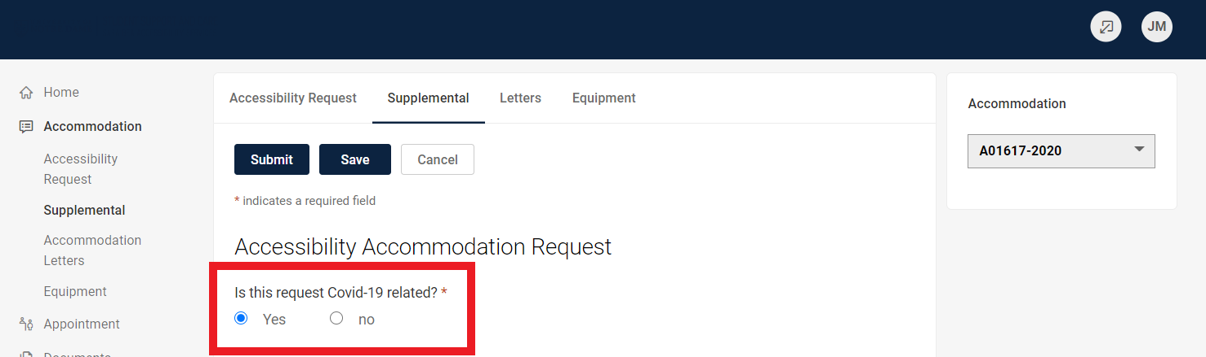

- If you are a graduate student, check Yes and answer the subsequent questions that appear. If you are not a graduate student, check No.
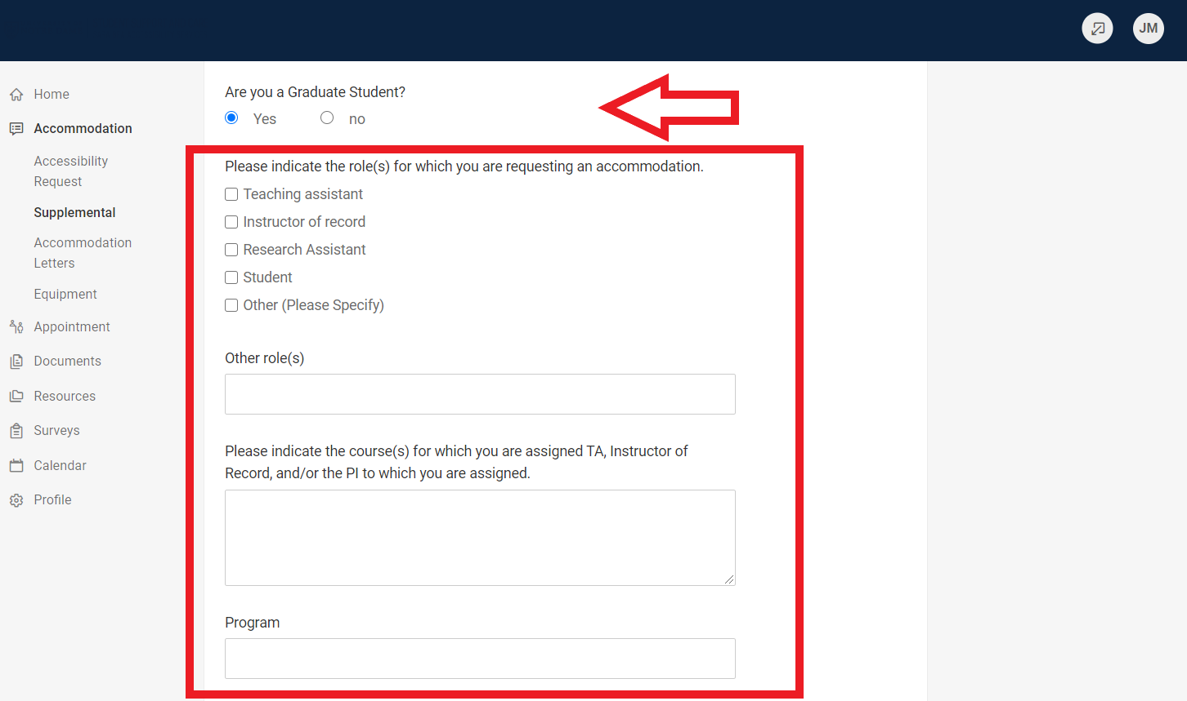

- From the Drop Down Menu choose the Accommodations you are requesting
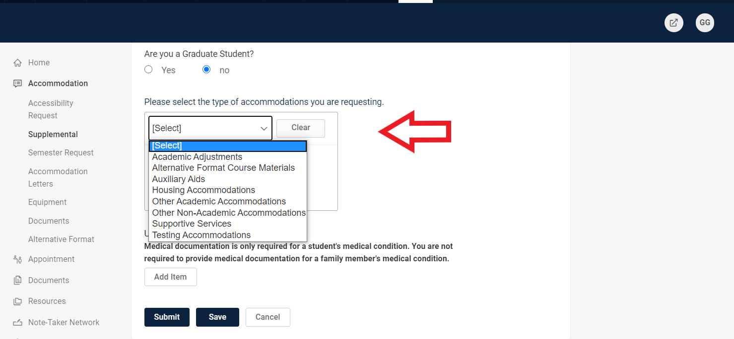

- If your request is not supported by documentation already on file at the Sara Bea office, please upload new documentation.
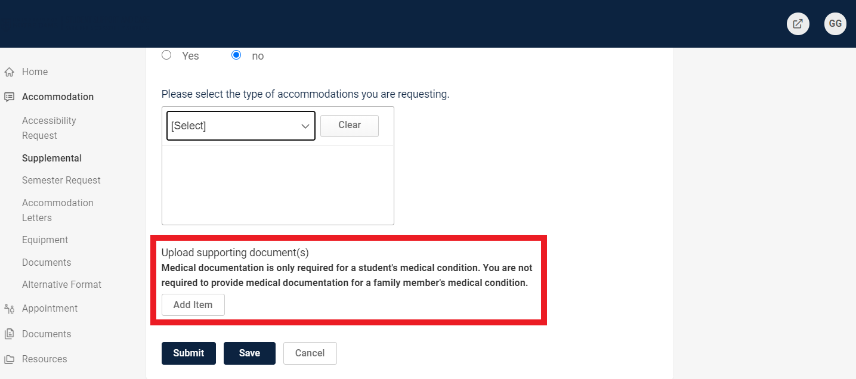

- Click Submit.
