Student AccessND Instructions
How to Download Notes

- In InsideND, Search “AccessND” and click on the logo to navigate to your Student page.
- You will then see your Student Home Page.
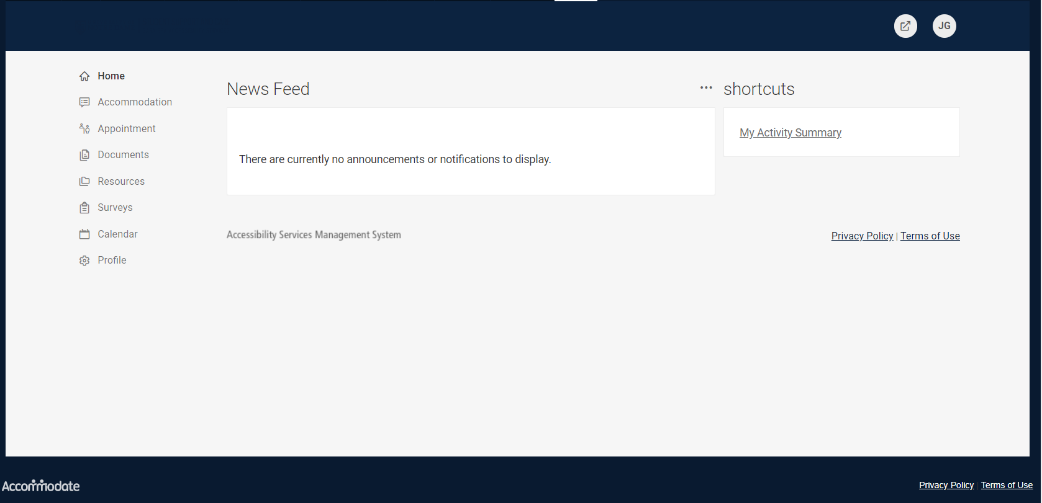

- Choose Note-Taker Network from the Left Side Menu.
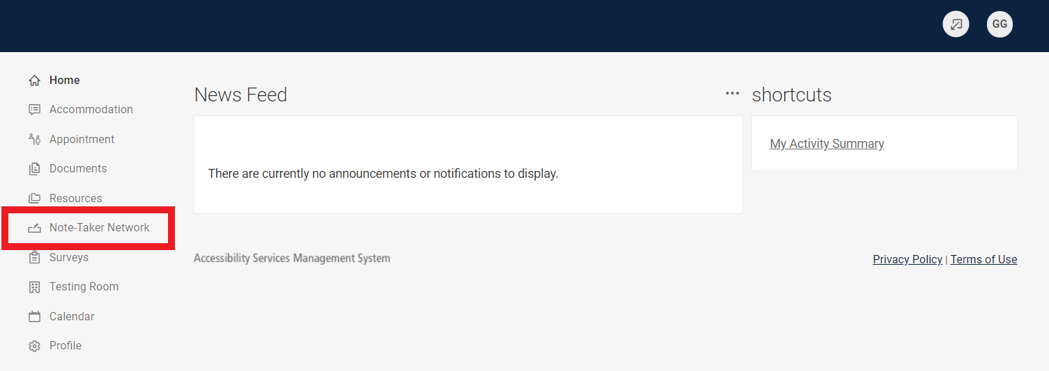
- Your notes will be listed in the order that they were uploaded. Under each title is a Download Option. You can download and save to your own computer.
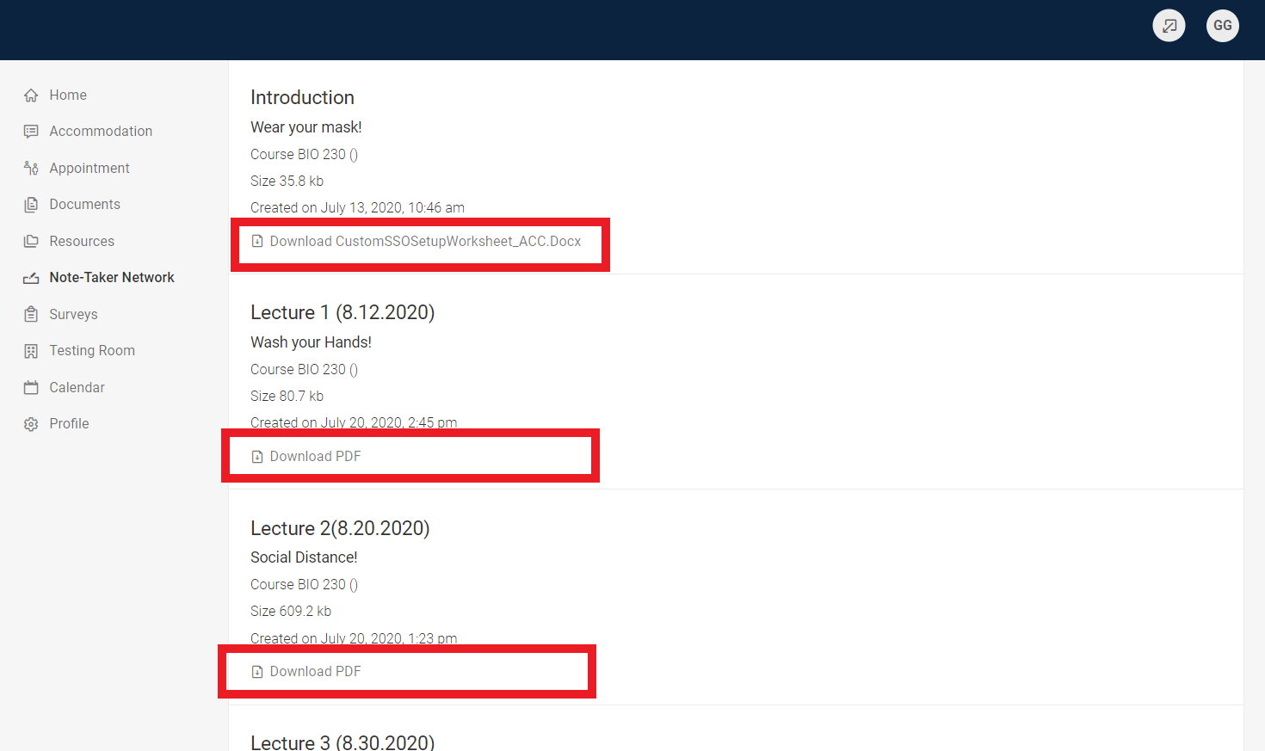

- To sort your notes by class, click More Filters.
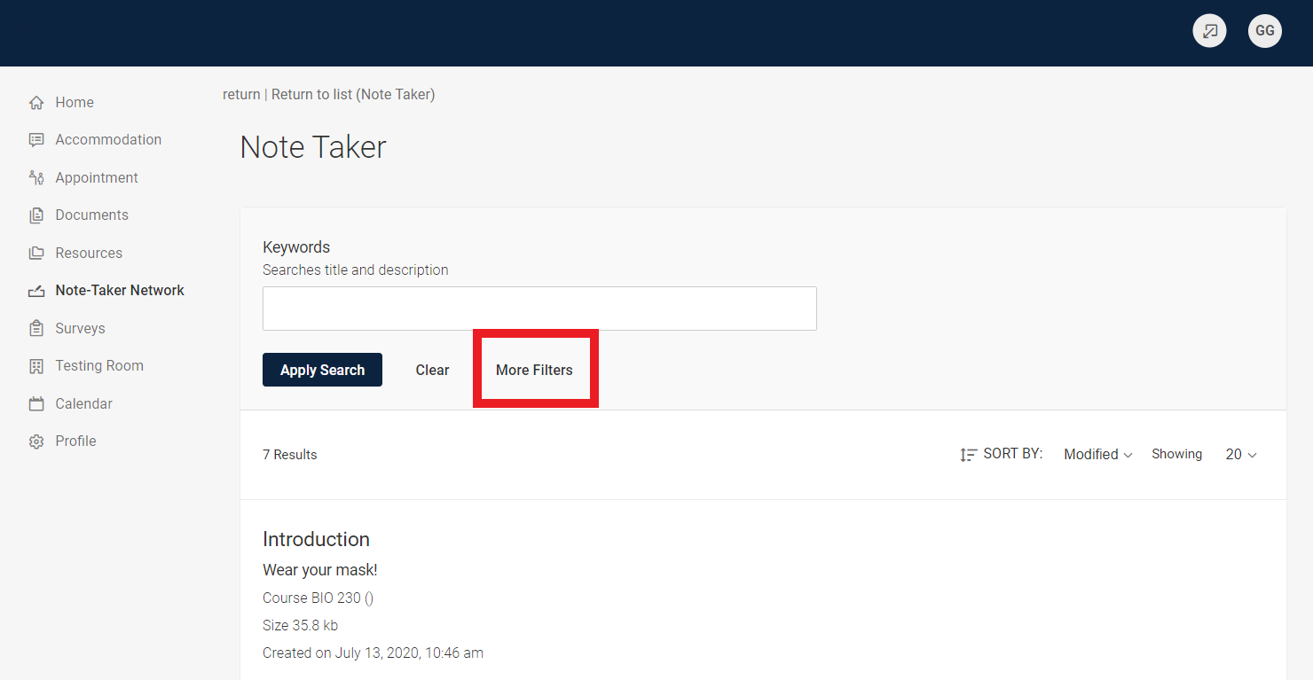
- Enter the Course you are wanting to view and Click Apply Search.

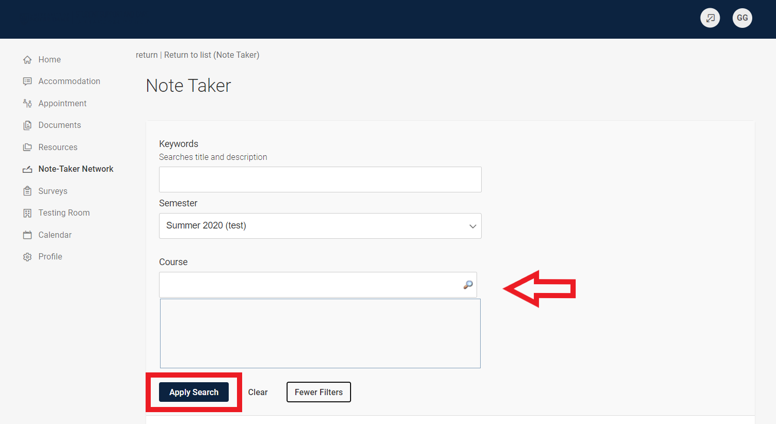

- You will then see only the notes from that class and can download the ones you’d like.
