Student Accommodate Training
Making an Appointment with Sara Bea staff
- In InsideND, Search for AccessND and click on the logo to navigate to your Student page.

- You will see your Student home page
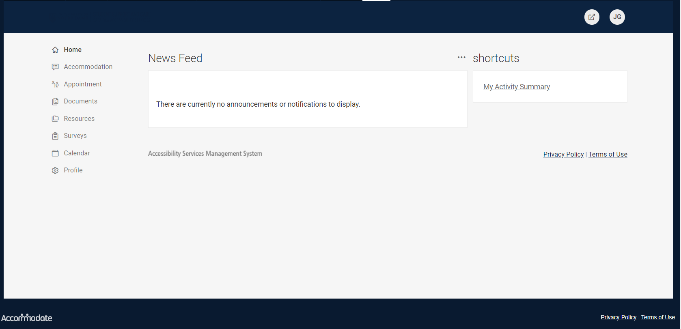

- Click on Appointment from the Left Side Menu

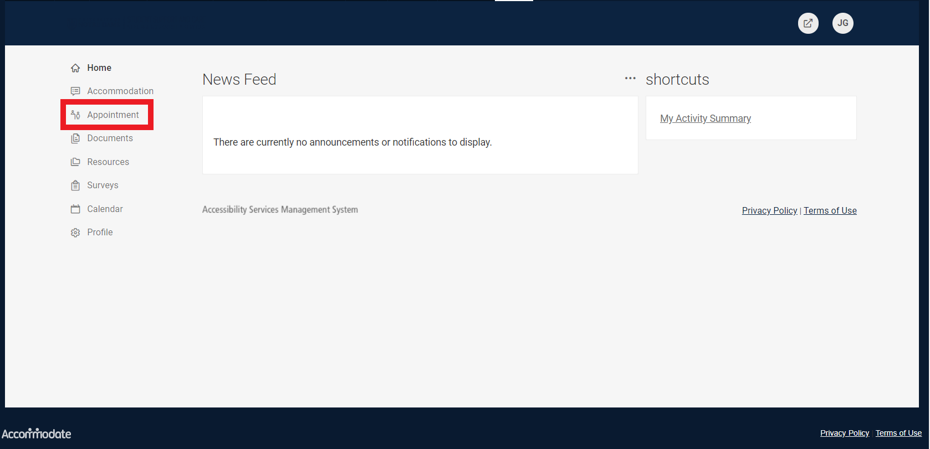

- Scroll down and click Request New Appointment
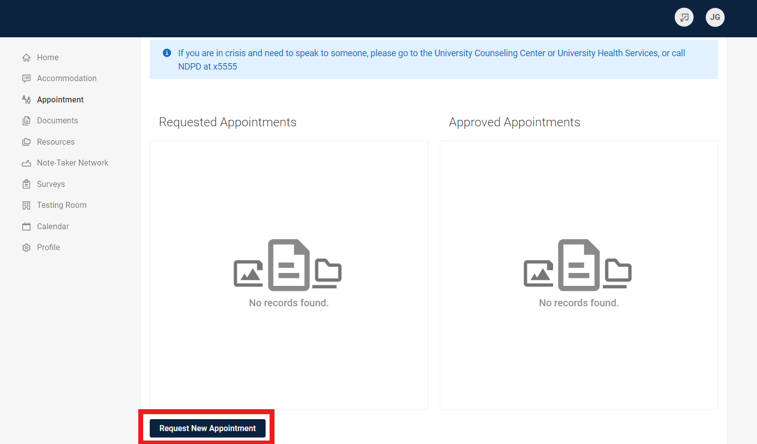

- Click on Type of Appointment

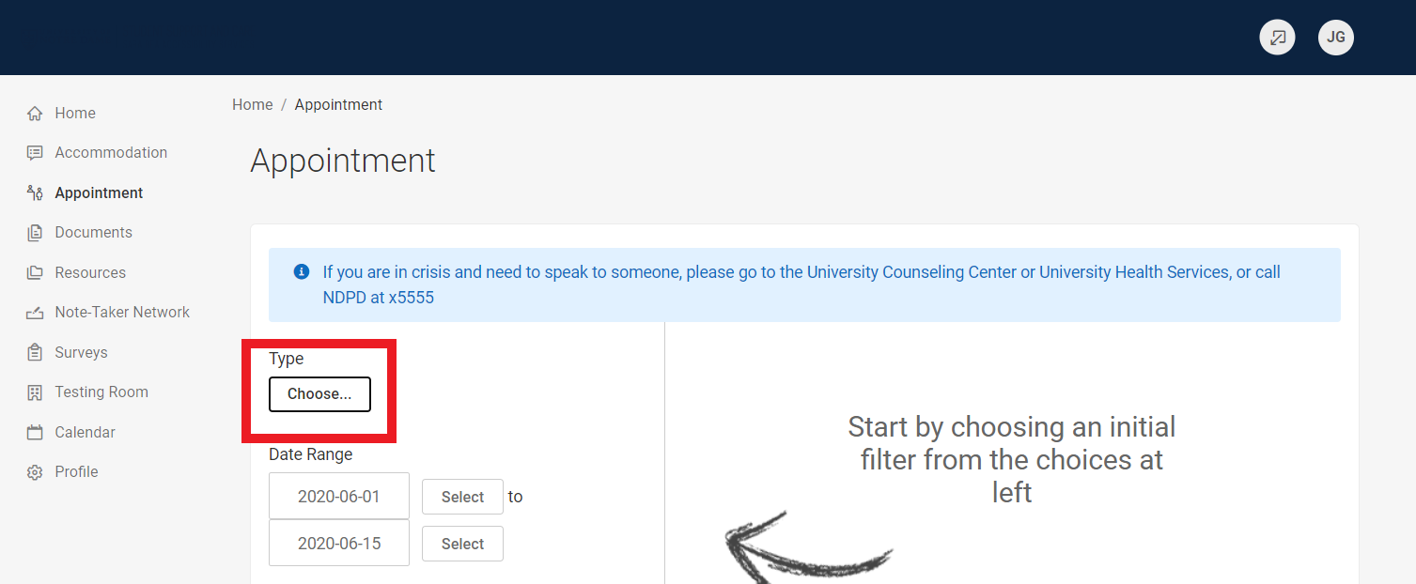

- A drop down box will appear. If you are a New Student who has not previously registered with the office, Click on New Student Registration. If you are already registered, Click on Accommodations for Registered Students and the type of appointment you need. If you are unsure, choose General Inquires.

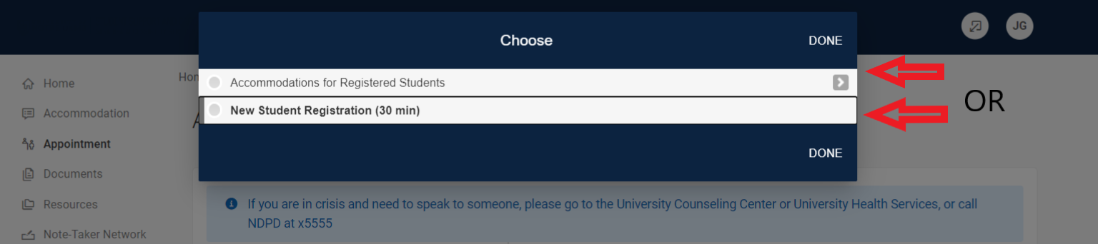
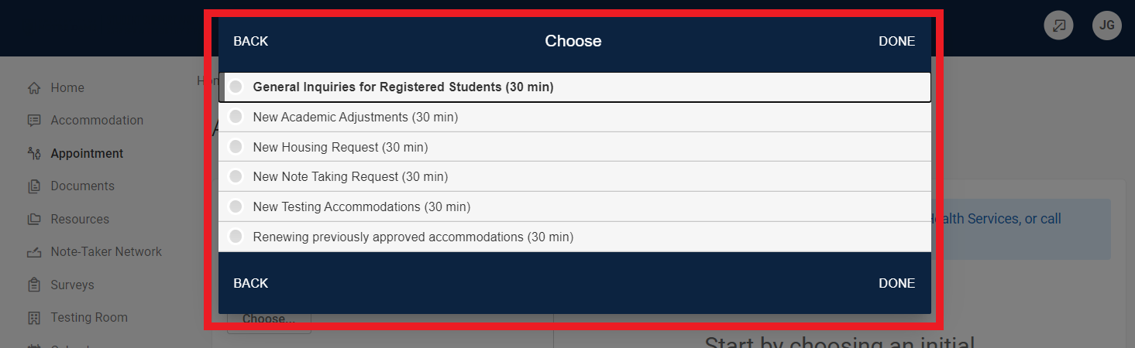

- Once you have chosen a type of appointment, you will enter the date and time you’d like to meet for an appointment. Under Location, there are 2 options. Amy Jobst is in Flanner 147; Scott Howland is in 248.

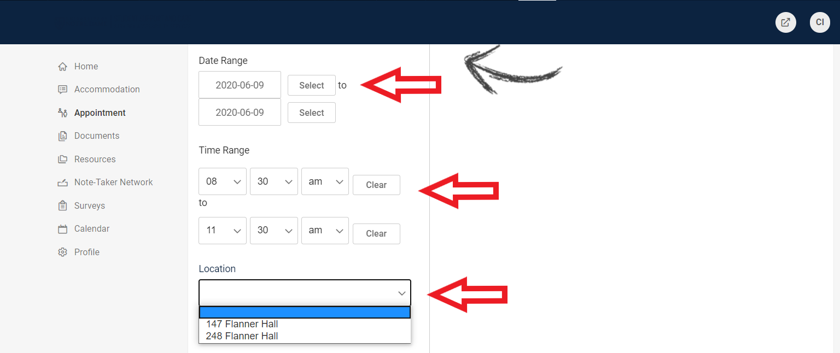

- The available times will appear on the right hand side of the screen. Click on the time that works best for you.

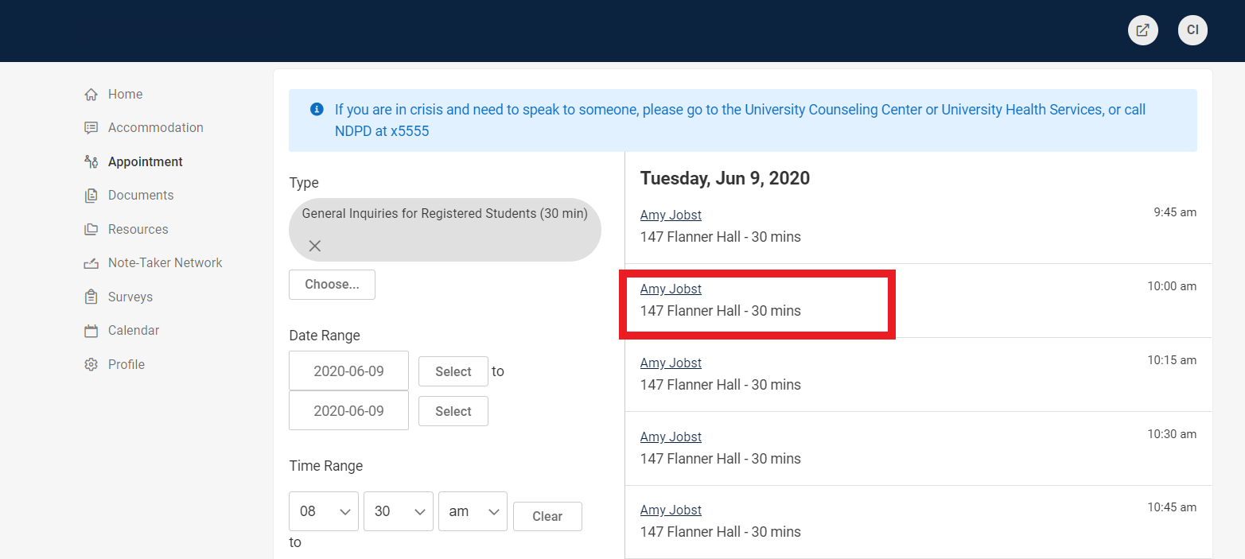

- A Confirmation pop-up box will appear.

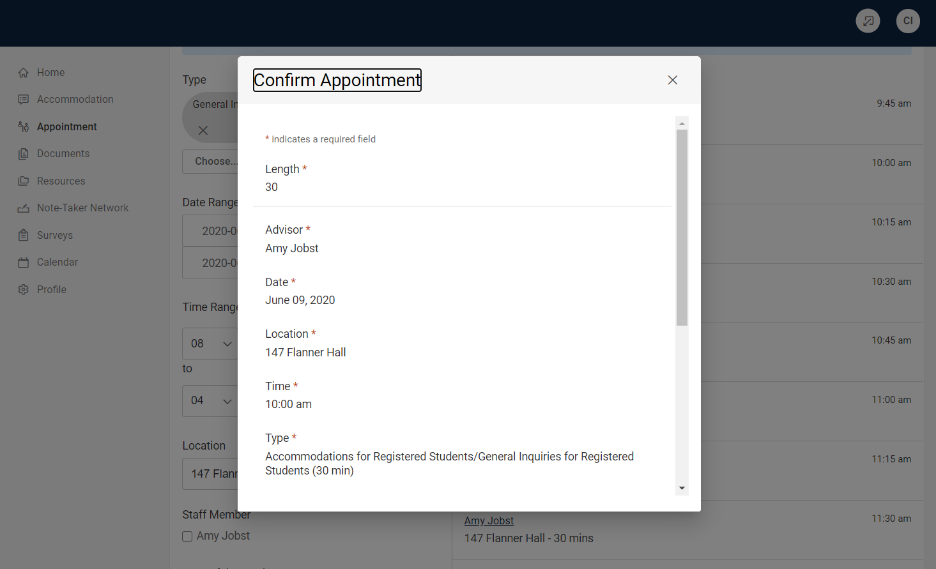

- Enter pertinent information in the Reason for Appointment box. Click “Submit Request”.

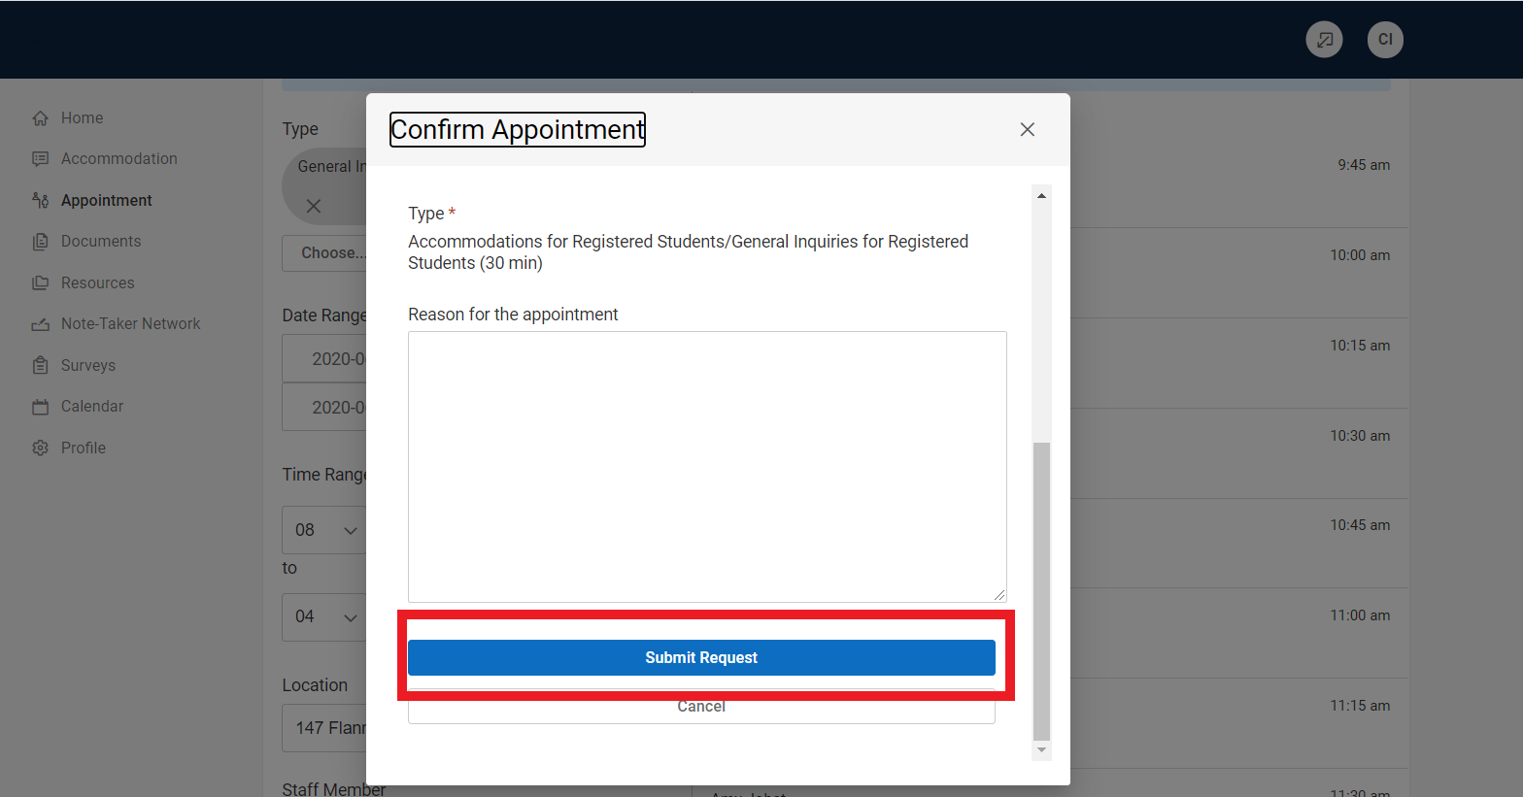

- You will see the Requested Appointment with date and time.

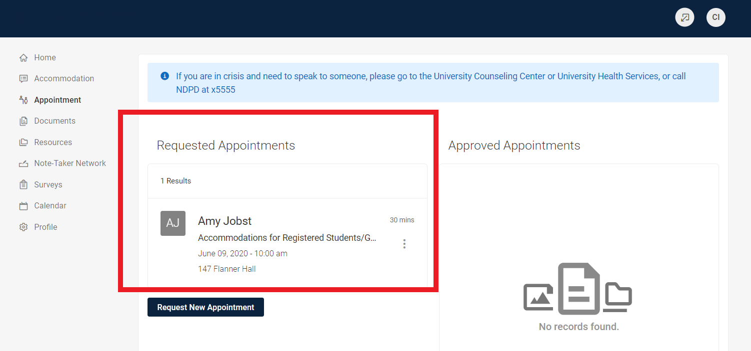

- Once the appointment has been approved by the staff member that you are meeting with, you will see it move to “Approved Appointments”.

