Accessible Content

Microsoft Word
Microsoft Word has a number of features that make it fairly accessible for students with visual impairments who may be using screen readers or braille devices. The following tips will help you implement basic accessibility principles into Word documents.

Font Choice and Size
Sans Serif fonts are generally easier to read. Avoid using SmartArt features in word or creating your own textboxes.

Use Headings
Headings allow screen readers and braille devices to jump between content and see how material is organized. Making something Bold, IN CAPS, or underlined is not creating Headings. To create accessible headings, use the Headings feature that is in the Styles Bar under the Home Tab.
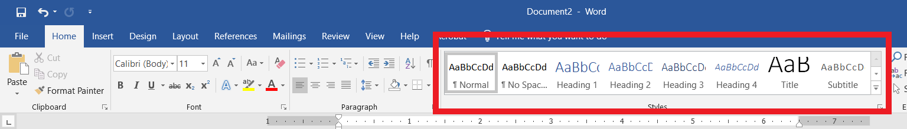

Use Lists
Lists are accessible with screen readers and braille devices if you use the built-in list features (either numbered or bullet points).

Add Alternative Text for Images
For any pictures used, add a description of the image. In most Word versions, you can do this by right clicking on the image, clicking Edit Alt Text and entering a description in the box.
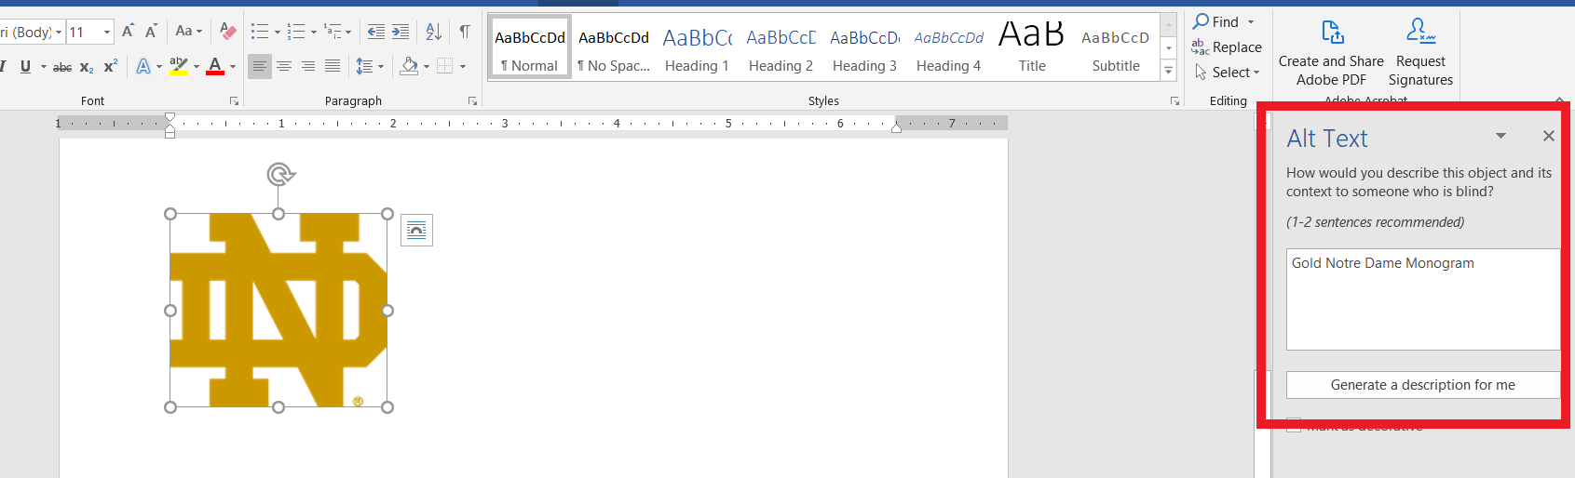

Use Helpful Hyperlinks
Avoid this: You will find the assigned homework here
Instead Try: You will find Week 3 Homework on the class Sakai page
If the document is likely to be printed by students, you will need to include the entire URL.

Export to PDF correctly
If you want to save your Word Document as a PDF, go to Save As and choose PDF as the document type. Do not Print to PDF as that will save the document as an unsearchable image for screen readers and braille devices

Check Accessibility
Microsoft has a built-in Accessibility Checker that you can find under the Review tab. It will highlight any potential problem areas that may not be accessible for all students.

Accessible Content

Powerpoint
PowerPoints are used in various ways in the classroom. Some instructors provide the slides ahead of time for students to print, others download them to Sakai, Canvas or another LMS for students to view. And others simply use them to highlight important parts during a lecture. Similar to Microsoft Word, PowerPoint has several built-in features that work with screen readers and braille devices. Use the following best practices to make your slides accessible.

Choose Design Template and Layouts
Use the built-in slide templates vs creating your own. The templates are designed to be read in the same order by a screen reader as a person without a visual impairment. Don’t add text boxes to slides as they do not appear on the Outline view and may be read out of order by a device.
When you are adjusting template colors, choose one with good contrast.

Use Unique Title for Each Slide
A screen reader can quickly jump from slide title to title. It is helpful if each slide has a unique title so the student can follow along. If the information you are presenting spills over into a second or third slide, consider using Slide Title 1 of 3 or Slide Title Continued so a student using a device can quickly track where you are in class.

Font Choice and Size
Sans serif fonts are generally more readable for those with visual impairments. Ideally, a PowerPoint Title is 44pt font and content is 36pt font. But content should not be any smaller than 28pt on slides.

Use Helpful Hyperlinks
Avoid this: You will find the assigned homework here
Instead Try: You will find Week 3 Homework on the class Sakai page
If the document is likely to be printed by students, you will need to include the entire URL.

Add Alternative Text for Images, Graphs and Tables
For any pictures, graph or table used, add a description of the image. Screen readers can’t make sense of images. To add a description, right click on the image/graph/table and click Edit Alt Text on the menu. For graphs and tables, be detailed as to what is learned from the graphic.

Video and Audio considerations
If you are embedding audio or a video, make sure the video is captioned or provide a transcript of the audio. Sara Bea Accessibility Services can help you with this process.

Export to PDF correctly
If you want to save your PowerPoint as a PDF, go to Save As and choose PDF as the document type. Do not Print to PDF as that will save the document as an unsearchable image for screen readers and braille devices

Check Accessibility
Microsoft has a built-in Accessibility Checker that you can find under the Review tab. It will highlight any potential problem areas that may not be accessible for all students.
Another way to check accessibility is to go to the View Tab and Click Outline View. If all your textboxes and content appears there, it should be readable to any device.

