Student AccessND Instructions
Exam Room Booking

- In InsideND, search for and click on AccessND.

- You will then see your Student Home Page.
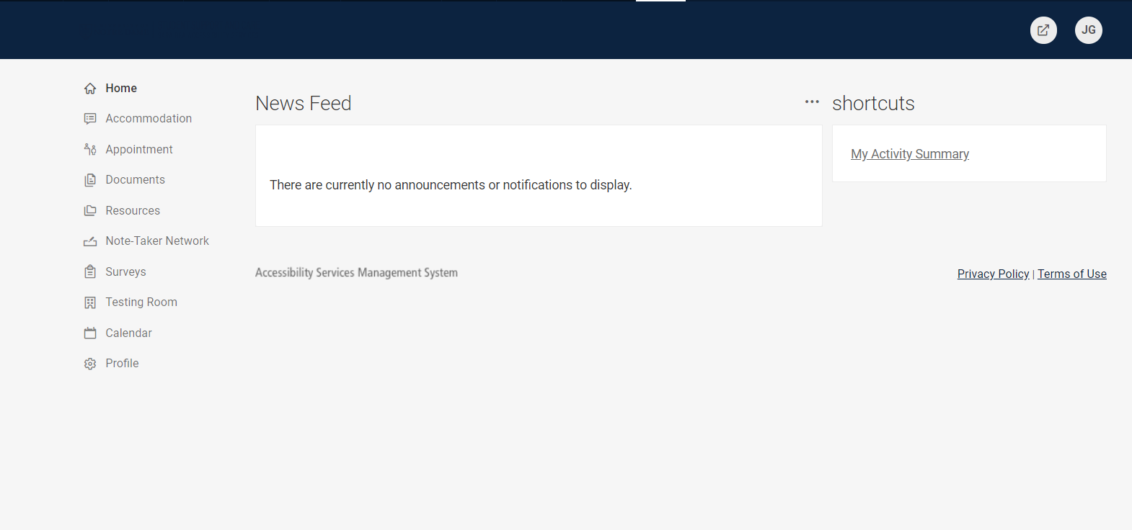

- Click on Testing Room.
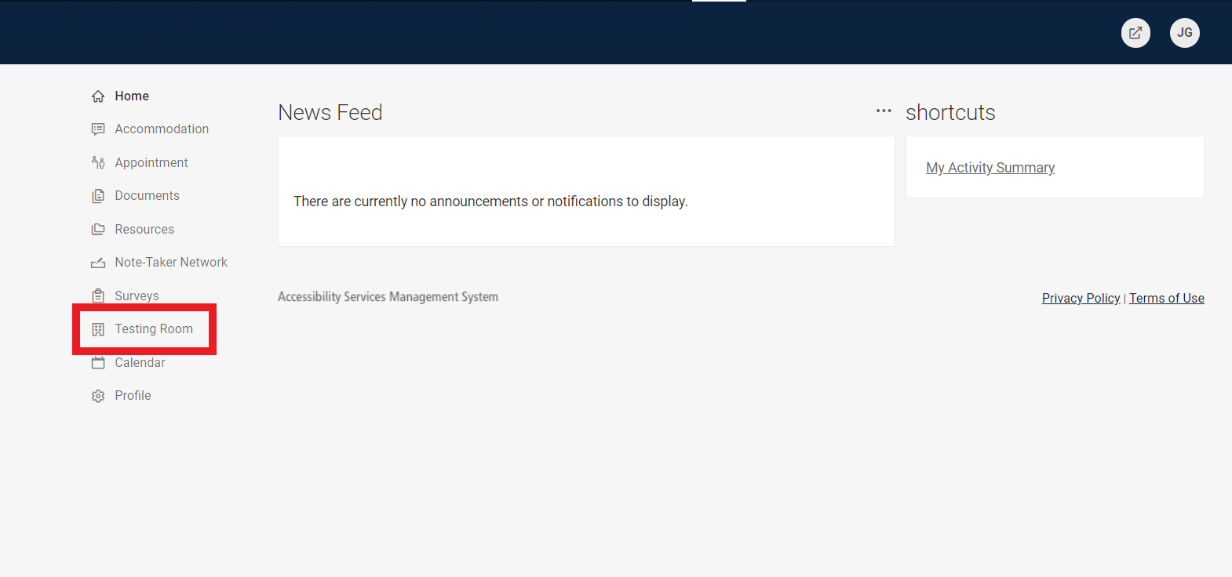
- Click on New Booking Request at the bottom of the screen
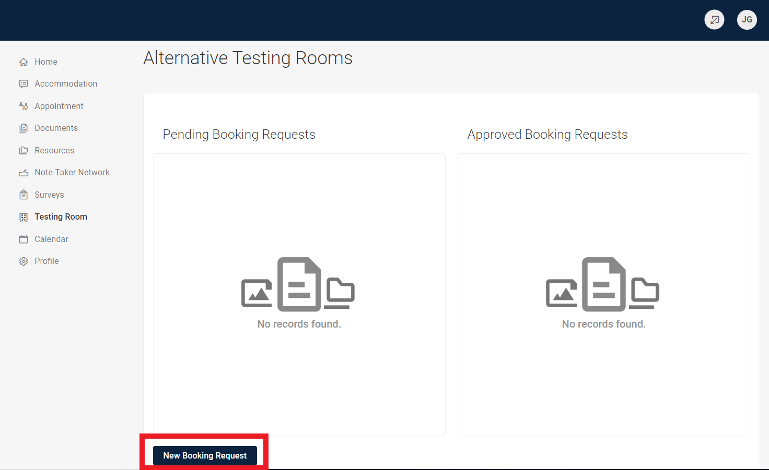

- From the drop down menu, click on the Course in which you have an exam.
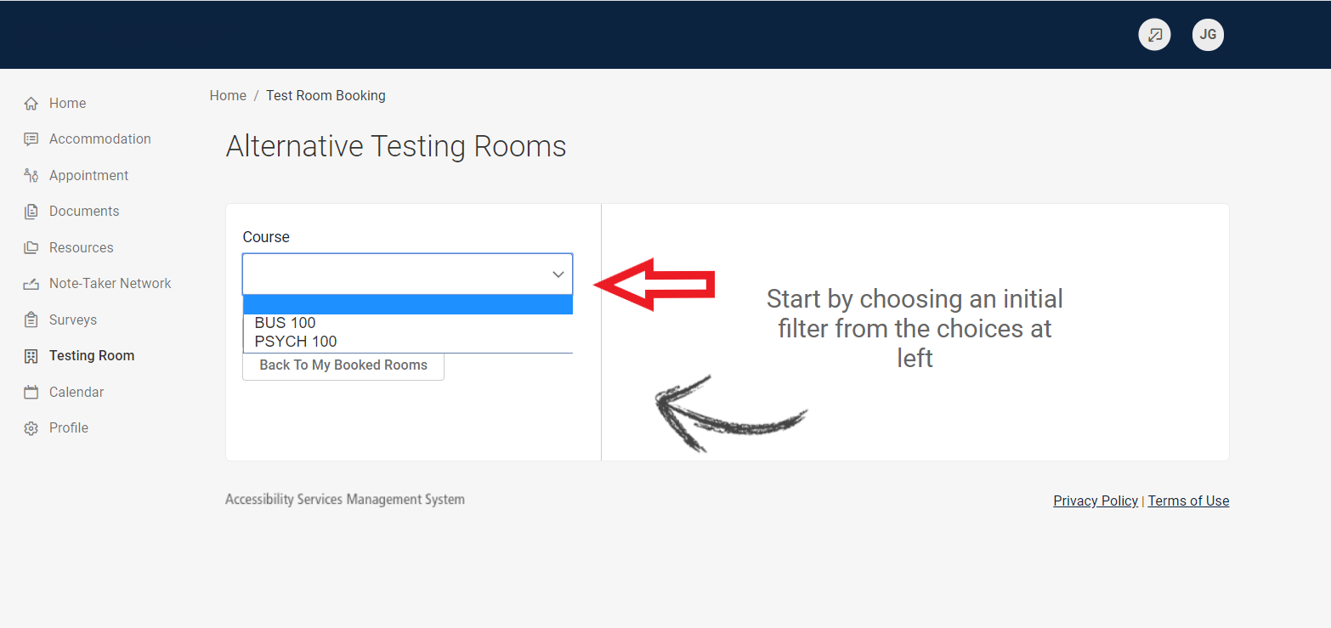

- Depending on whether your Instructor has already uploaded the exam to AccessND, the following steps will change.

- If your screen does not look exactly like this, then you will want to skip to step 15 because your Instructor has already uploaded a copy of the exam. If your instructor has uploaded the exam, you will not see the question about a Final Exam.

These are instructions for if you Instructor has NOT YET uploaded the exam.
Choose the Date and Time of your exam. While the program allows for a range of dates/times, you must take your exam at the same time as your class, unless you have permission from your instructor to take the exam at a different time.
Click “Yes” or “No” on whether the exam is a final.
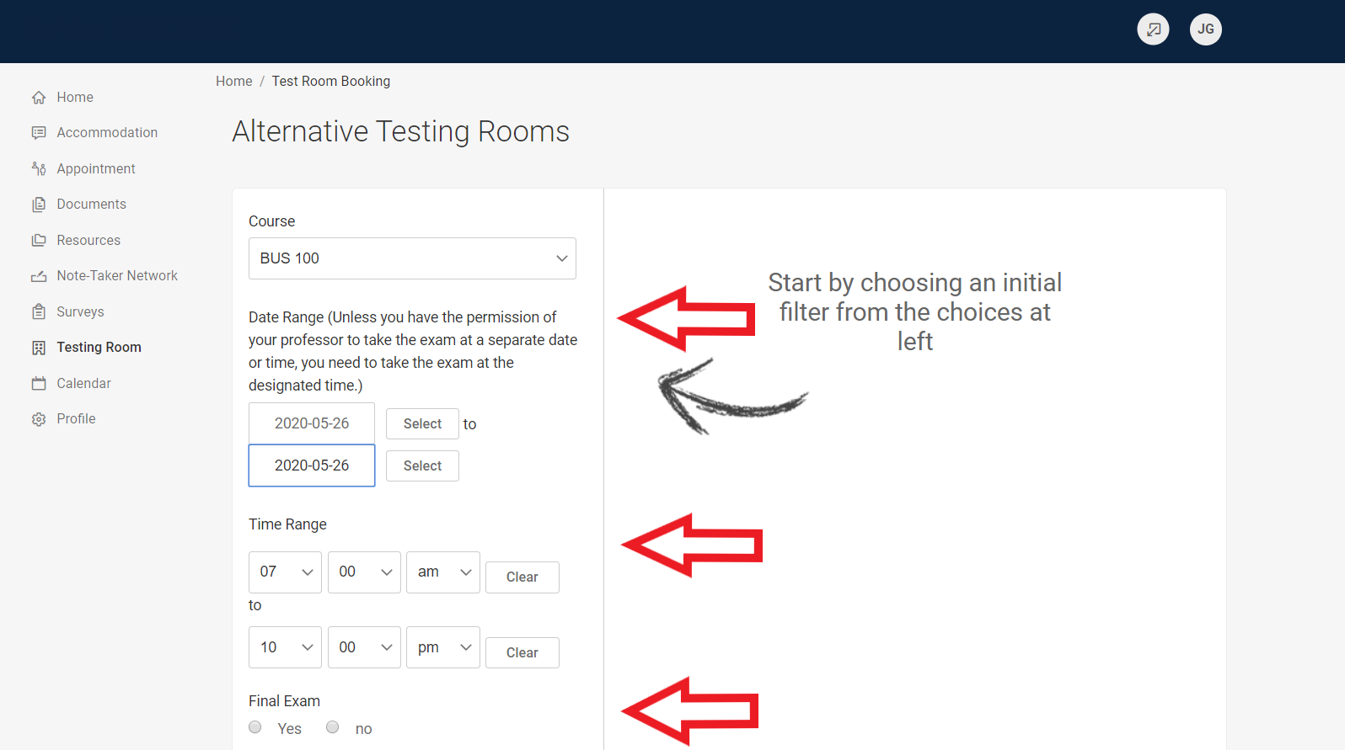

- From the drop down menu under “Building”, choose Flanner Hall. You will see available rooms pop up on the right hand side of the screen. If you want to change any of your search criteria, simply make edits to the date and time and click Refine Results. Leave “Rooms” and “Days of the Week” blank.
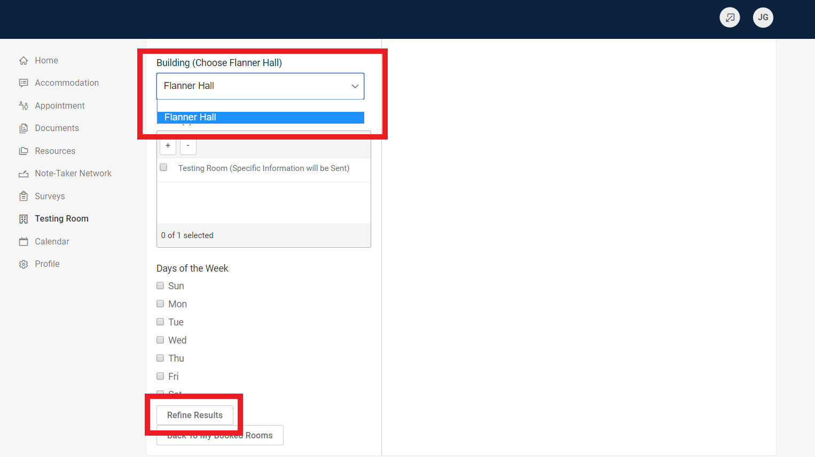

- Click on the Time that you want to start your exam.
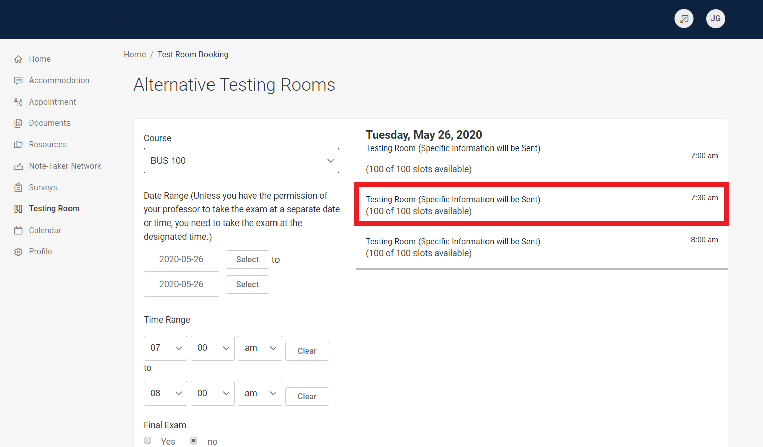
- A pop-up box will appear. You need to enter a Title for the Exam. (Exam 1 or CHEM 10000 midterm, etc.)
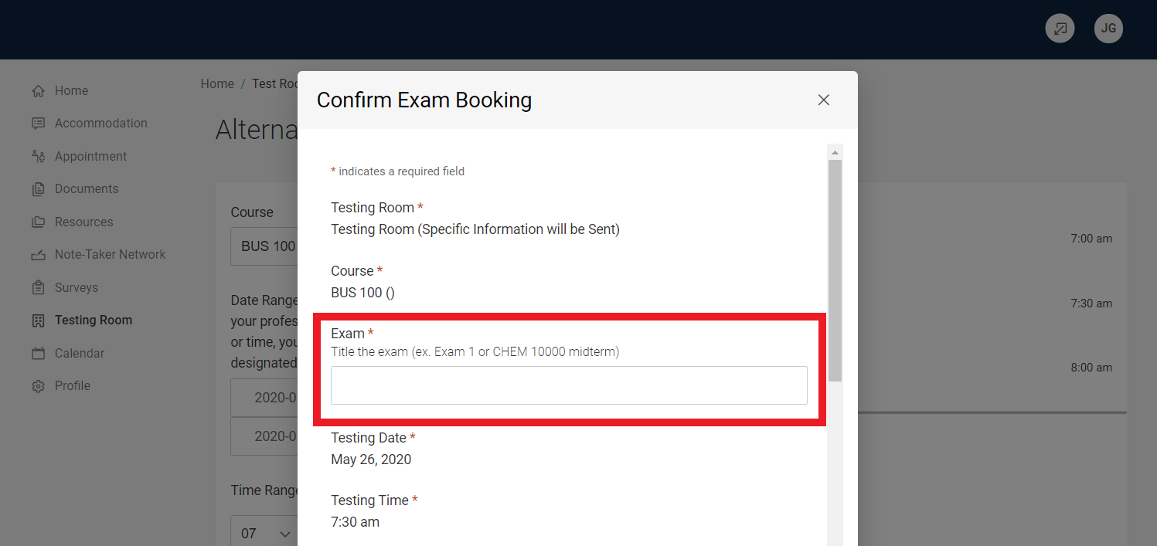

- Notice that the length of the exam (in minutes) will automatically populate based on any extended time you may receive. Sara Bea staff will adjust that time as needed based on any new information from the instructor.
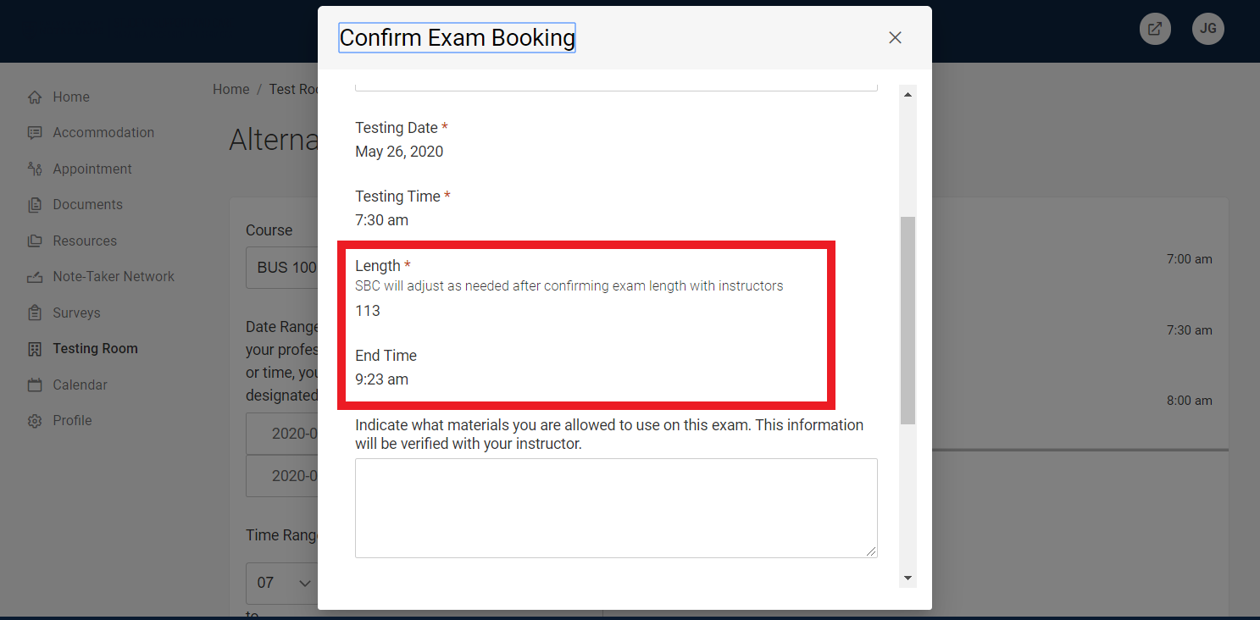
- Indicate what materials you are allowed to use on the exam. This information will be verified with the professor.
Click “Submit Request”
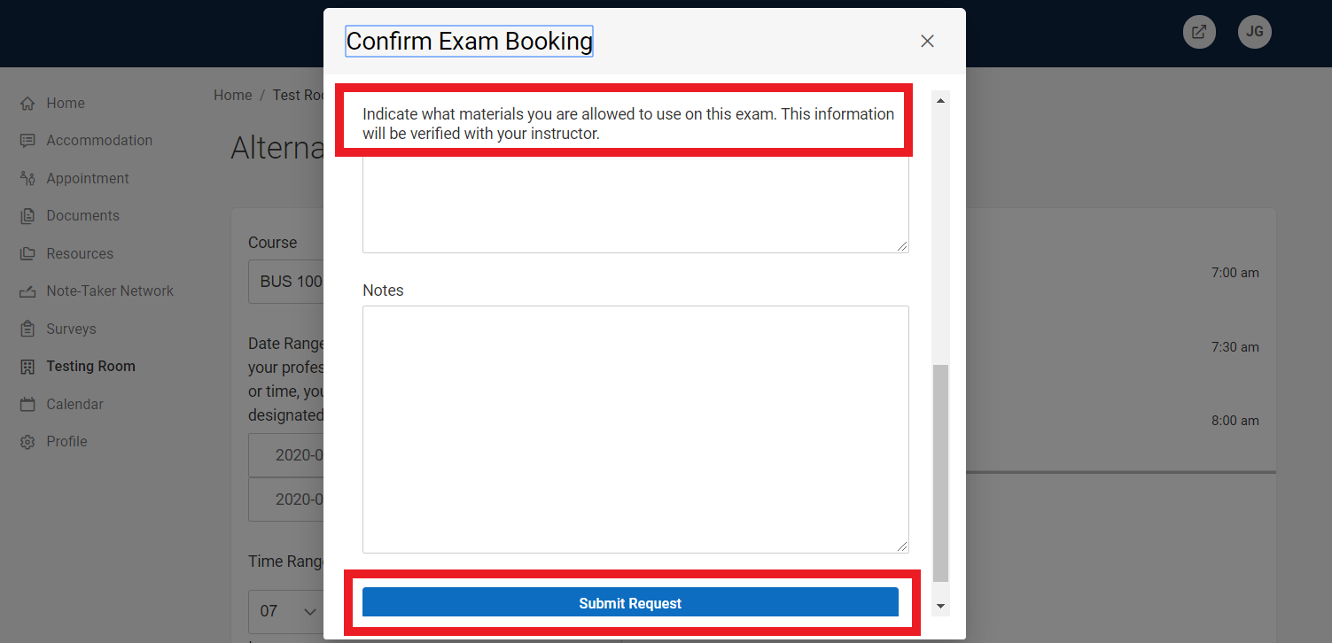
- You will see the details of your exam in “Pending Booking Requests” until the exam is approved by our office.
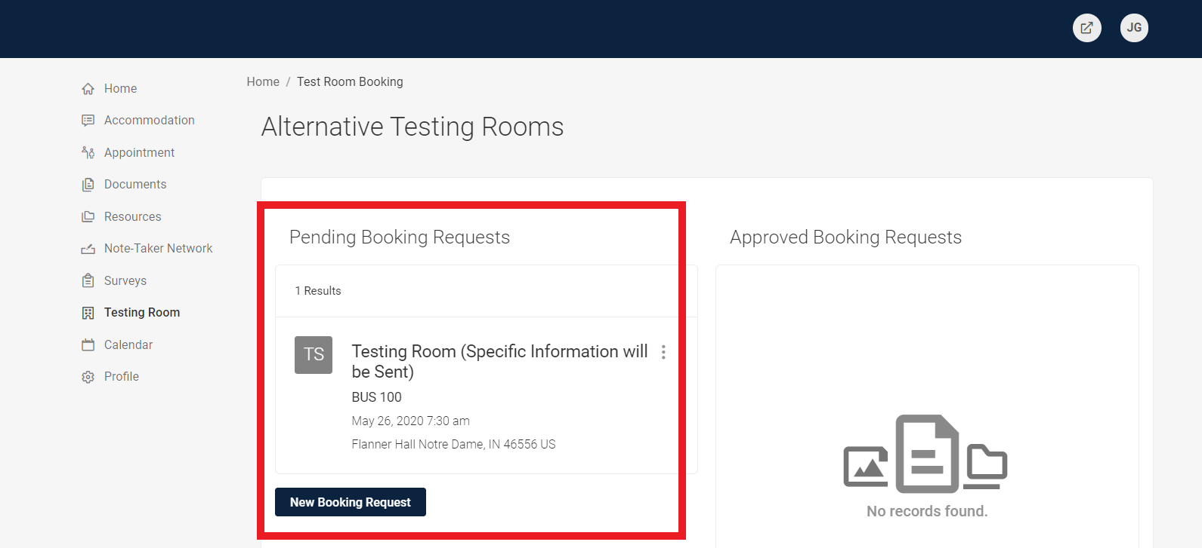

- After it has been approved, you will see it listed under Approved Booking Requests.
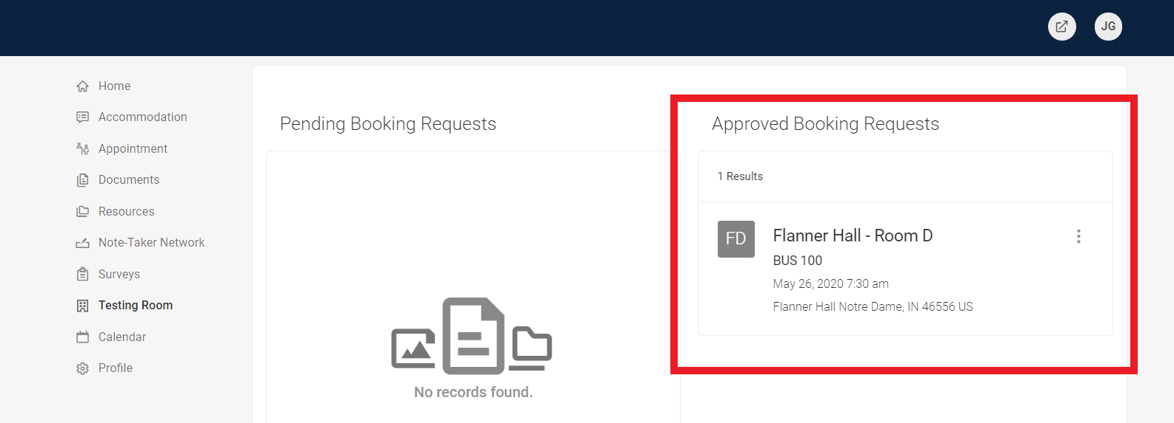

- The following instructions are for an exam when the Instructor has already uploaded a test. These instructions follow step 7 above.
Choose the Date and Time of your exam. While the program allows for a range of dates/times, you must take your exam at the same time as your class, unless you have permission from your instructor to take the exam at a different time.
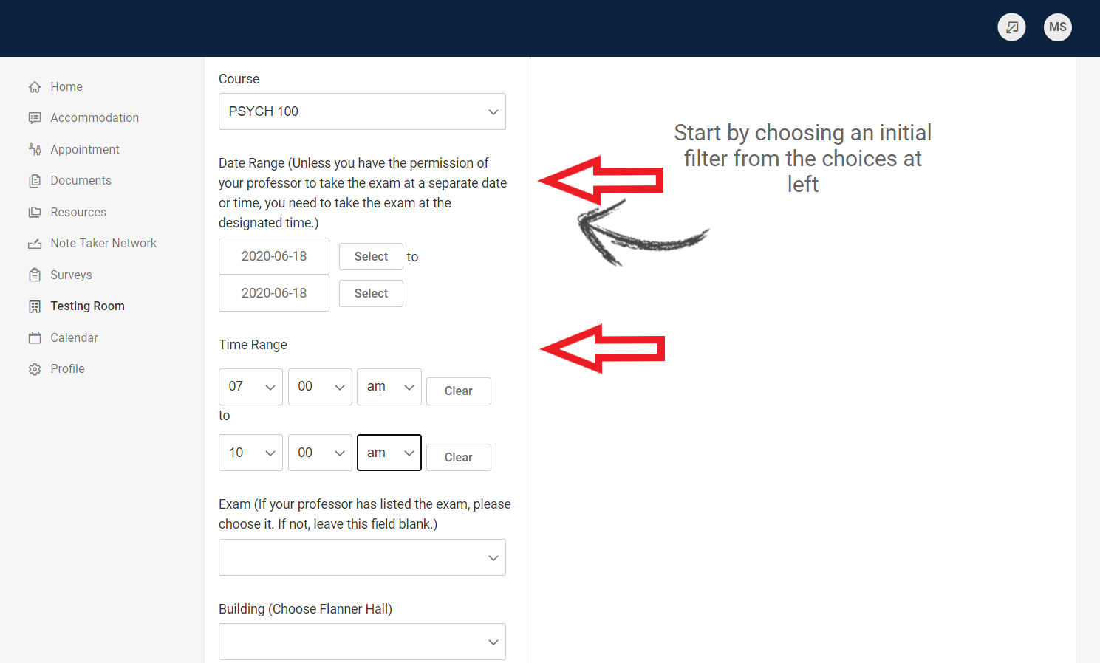

- Under the Exam drop down box, Choose the exam that your Instructor has uploaded. Your Instructor will have titled it.
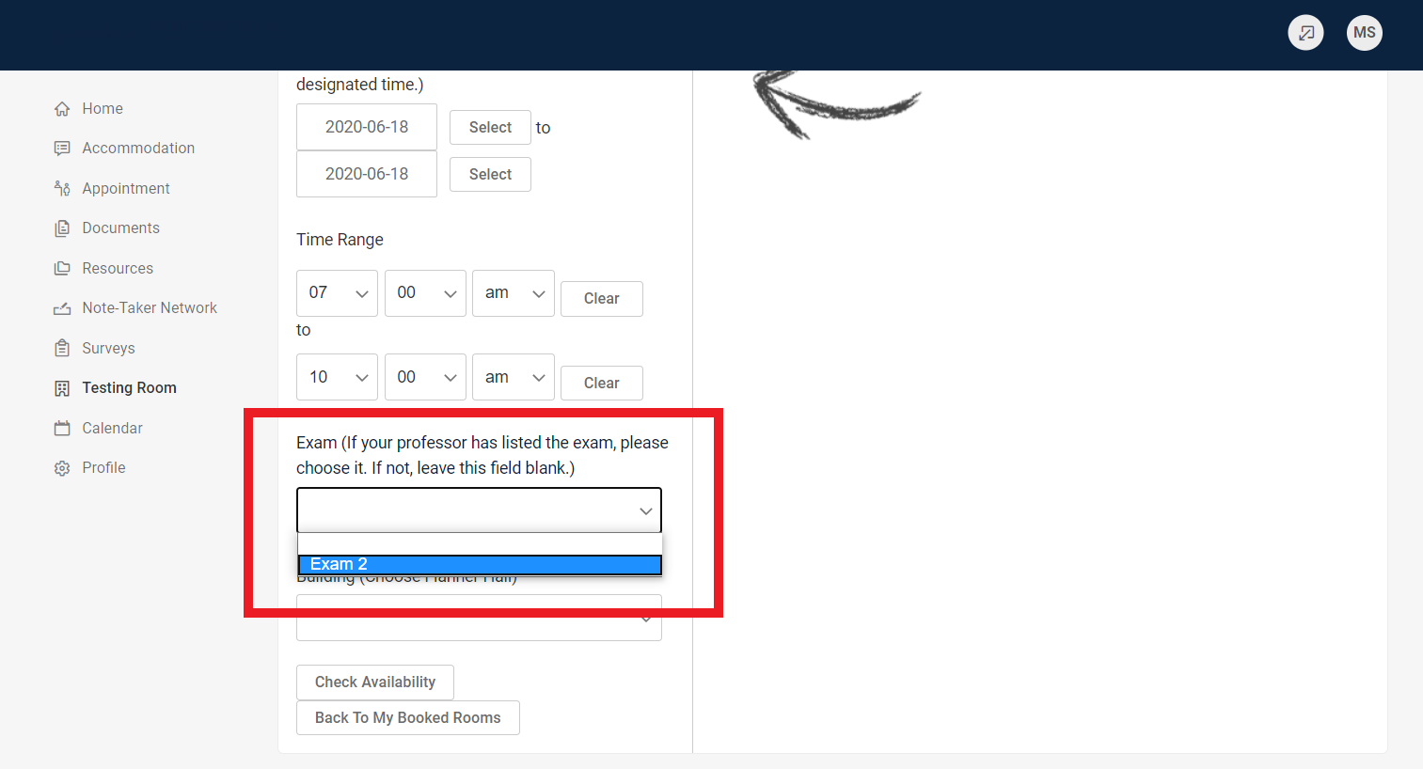

- As soon as you choose the exam, you will see available rooms pop up on the right hand side of the screen. If you want to change any of your search criteria, simply make edits to the date and time and click Refine Results. You do not need to choose anything under Building.
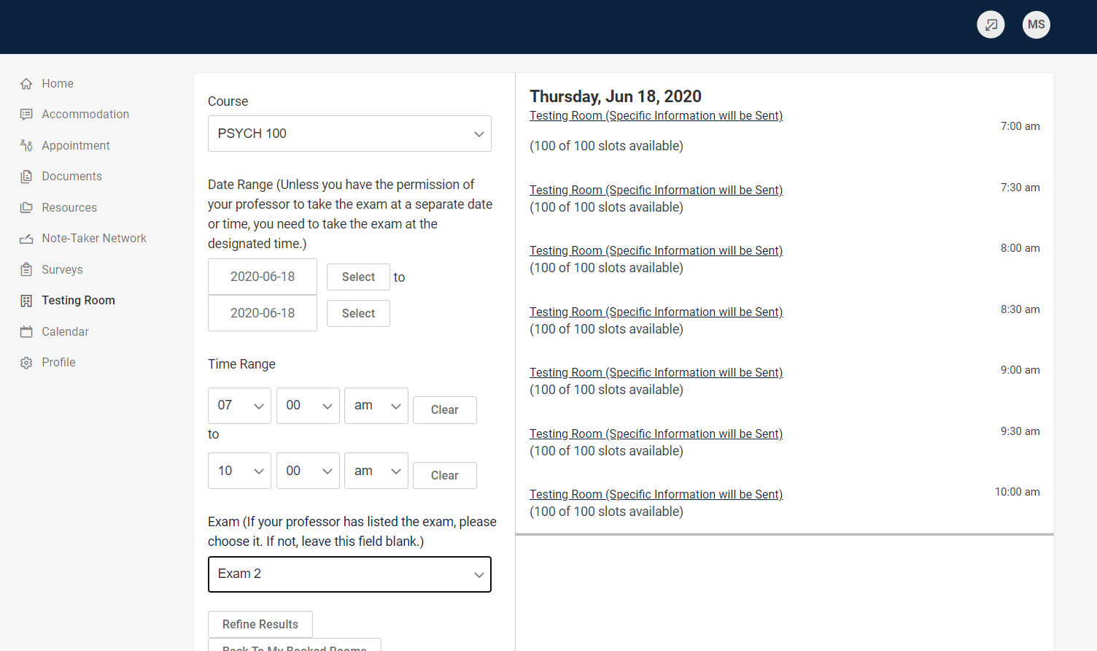

- Click on the Time that you want to start your exam
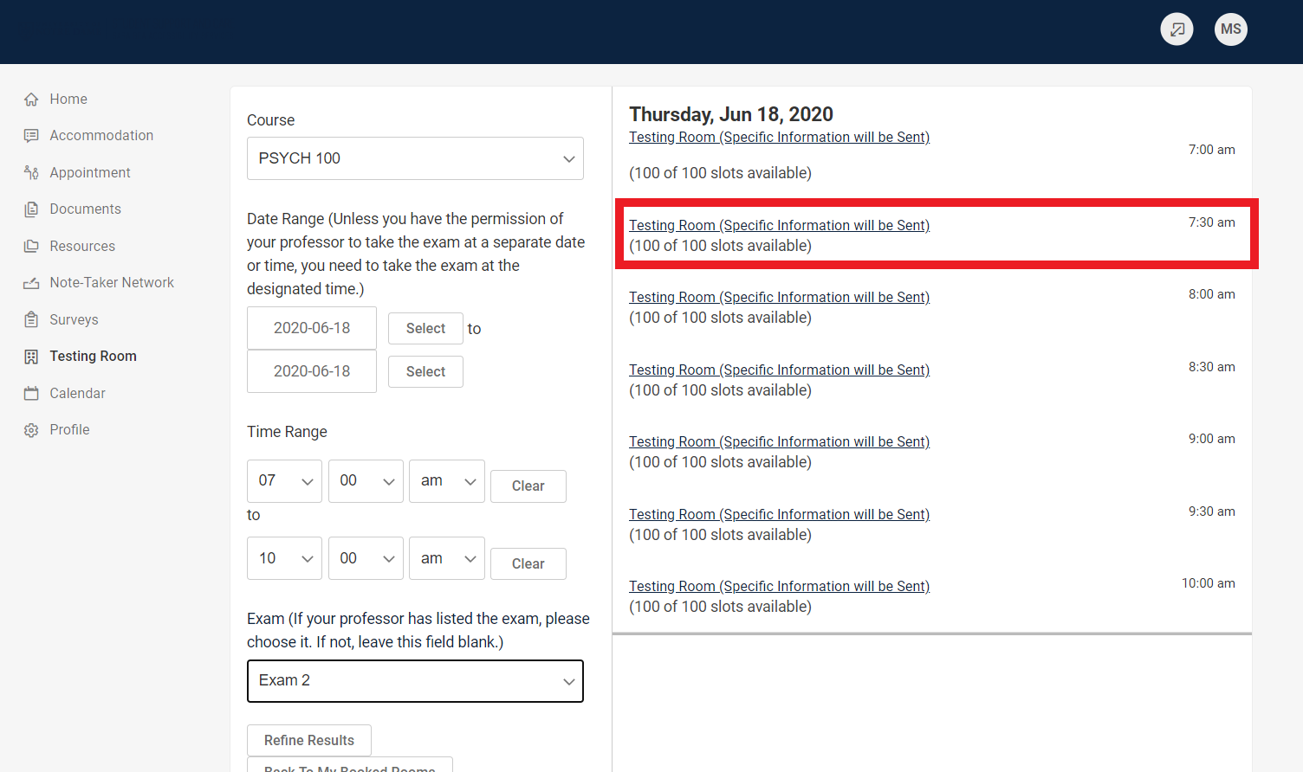

- A pop-up box will appear. Notice that the length of the exam (in minutes) will automatically populate based on any extended time you may receive. Sara Bea staff will adjust that time as needed based on any new information from the instructor.
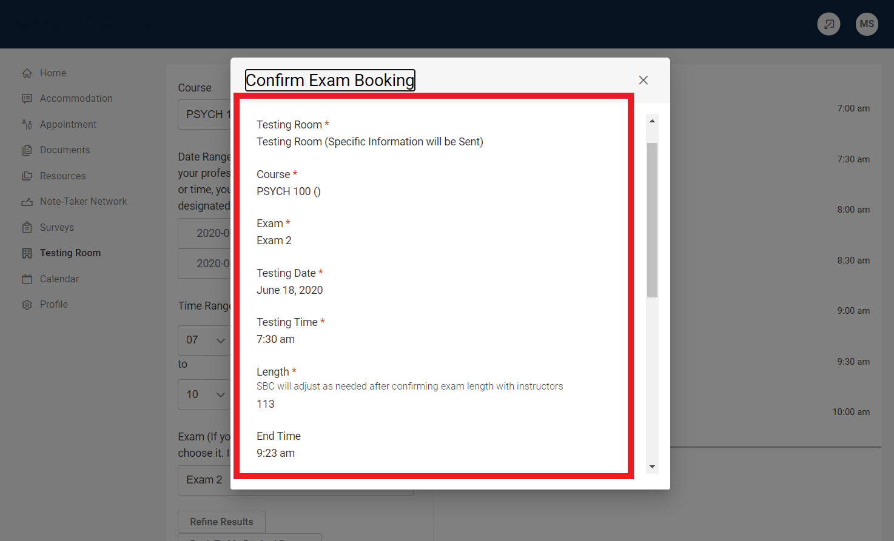

- Indicate what materials you are allowed to use on the exam. This information will be verified with the professor.
Click “Submit Request”
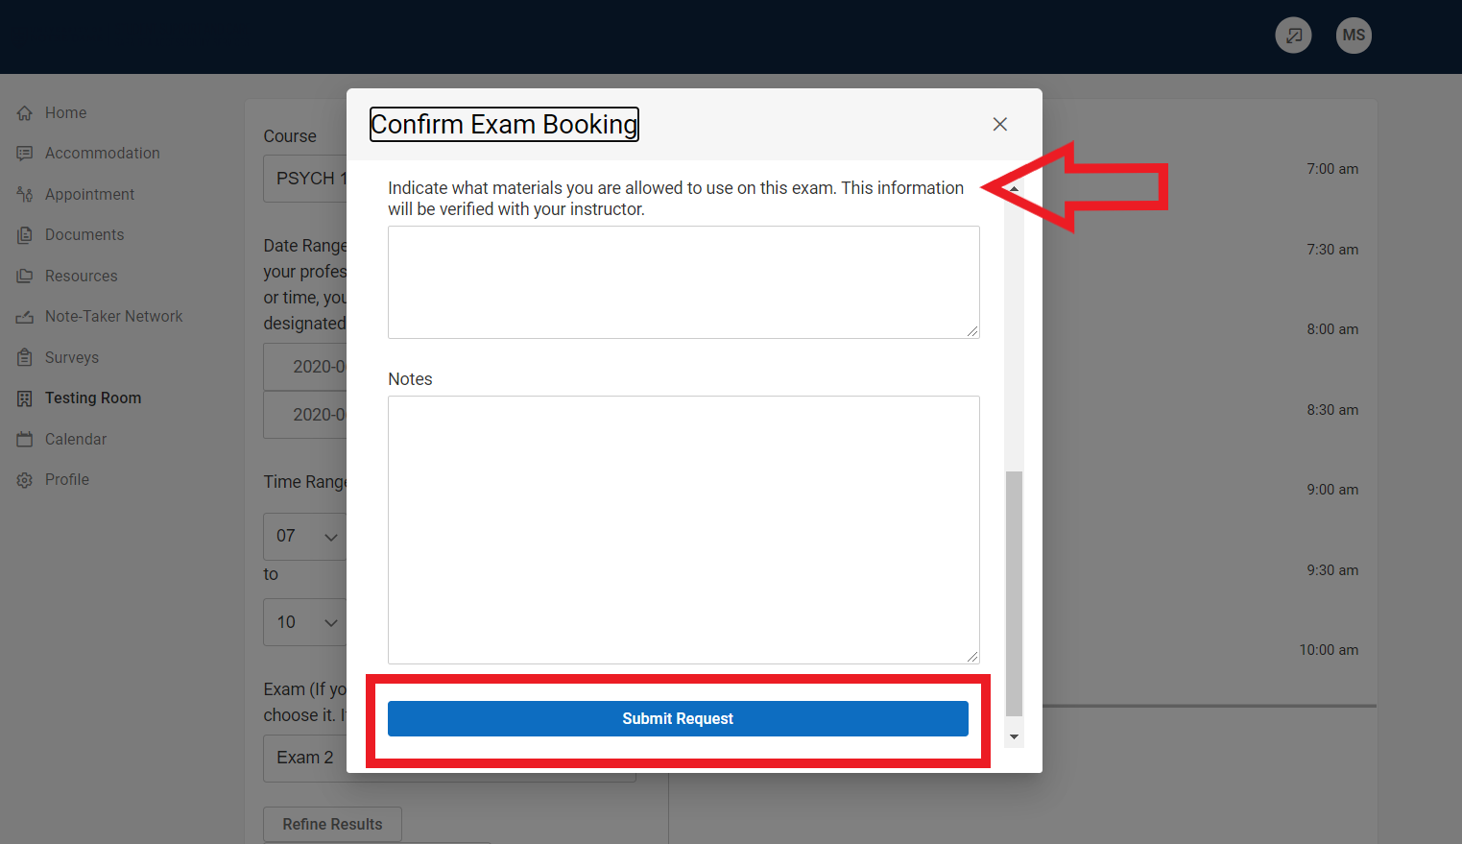

- You will see the details of your exam in “Pending Booking Requests” until the exam is approved by our office.
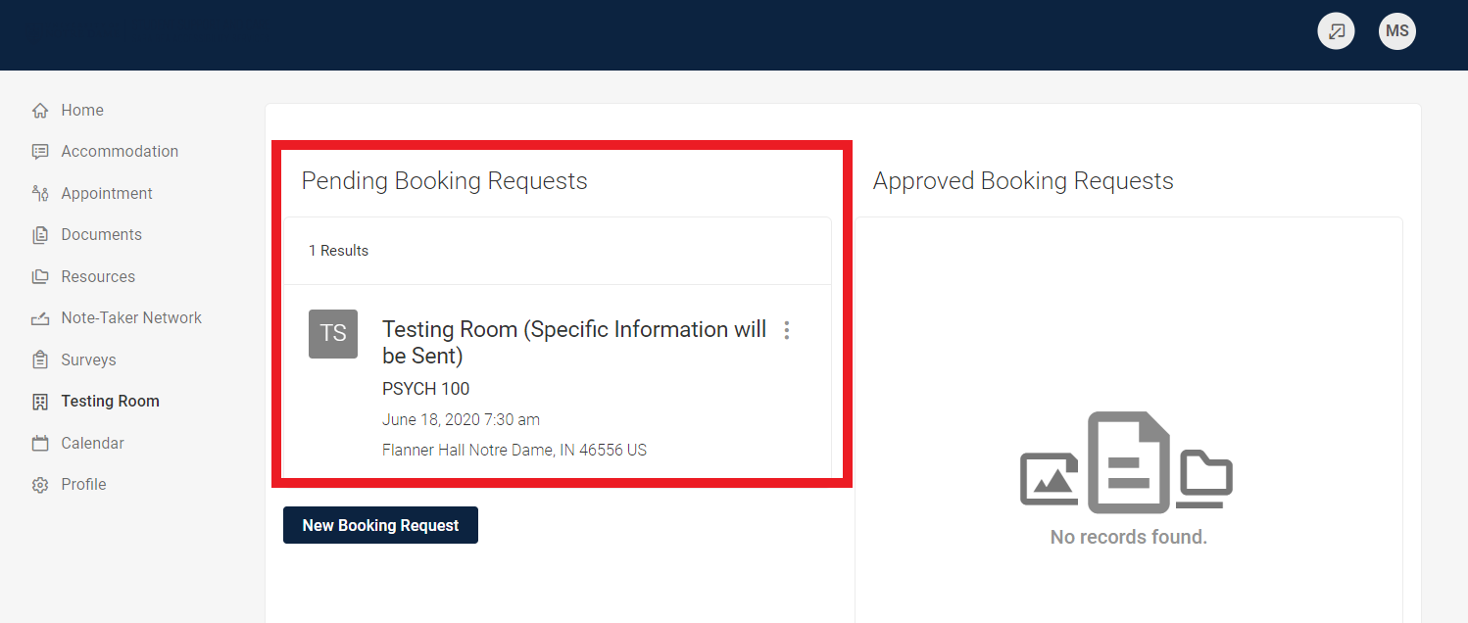

- After it has been approved, you will see it listed under Approved Booking Requests.
