Student AccessND Training
Alternative Format Request

- In InsideND, Search “AccessND” and click on the logo to navigate to your Student page.

- You will then see your Student Home Page.
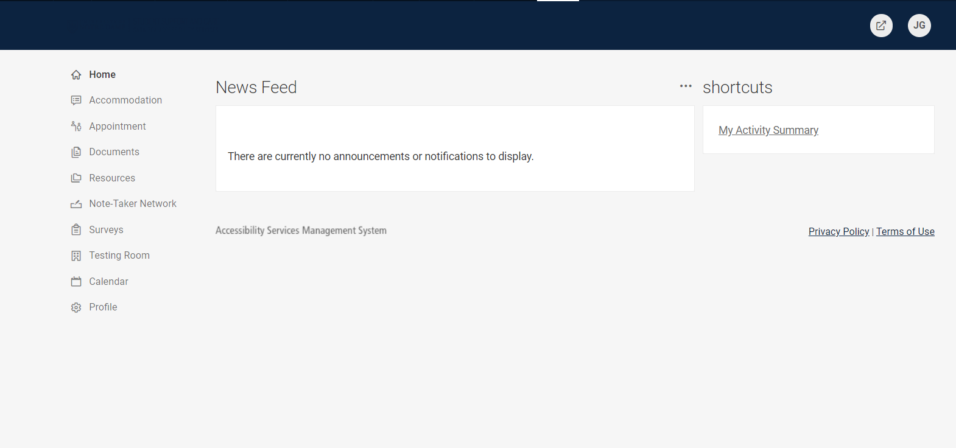

- Click on Accommodation and then choose Alternative Format from the options below.
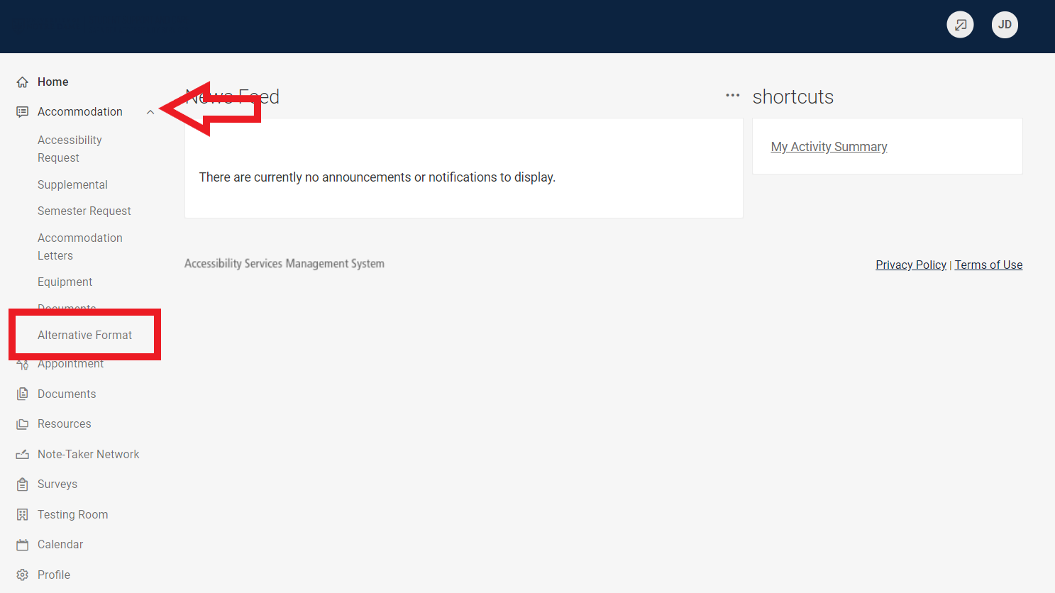

4. Click on Student Entered along the Top Menu Bar
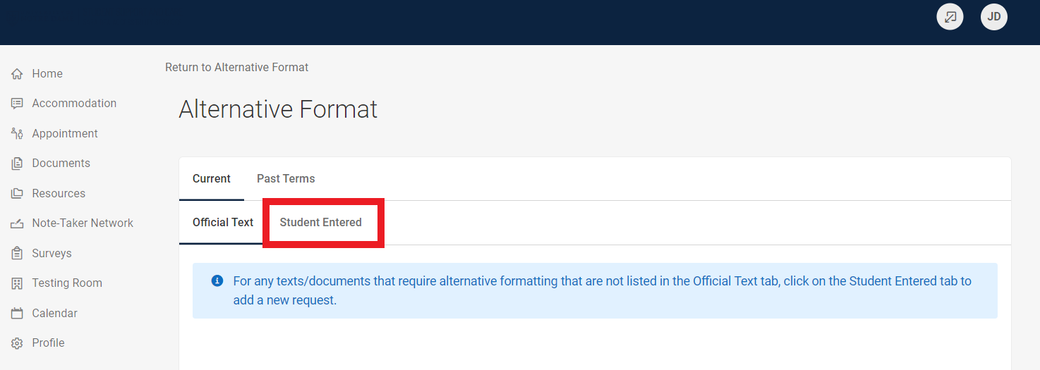

5. Click on Upload Document for Alternative Format Request
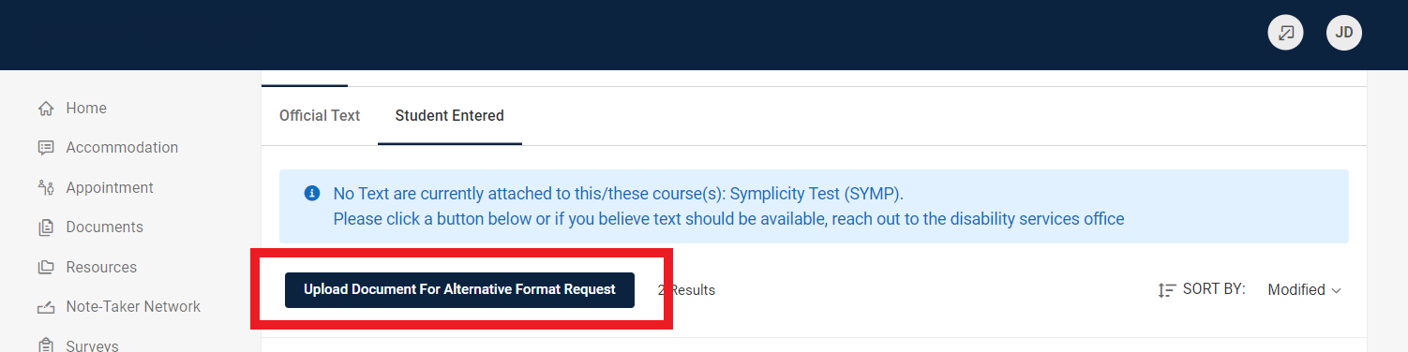

6. Enter as much information as you can related to the book or article, including ISBN, Title and Author. From the Semester Drop Down Menu, choose which semester you are requesting this item.
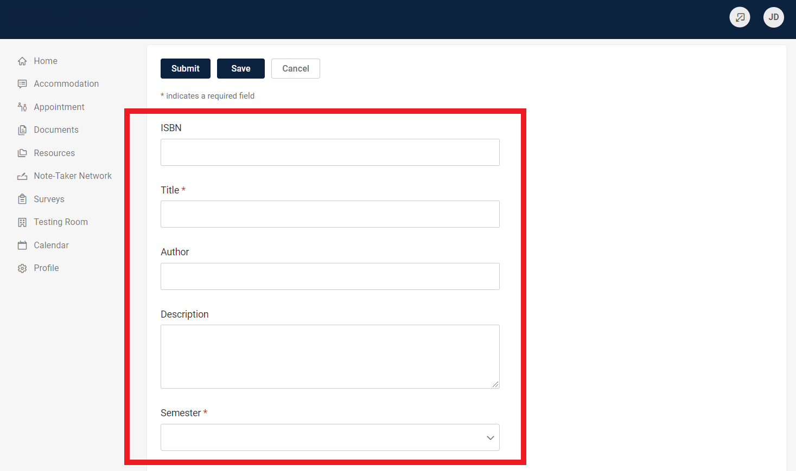

7. If you have a proof of purchase, you can upload that. It is not required. From the Drop Down Menu, choose the type of format you need.
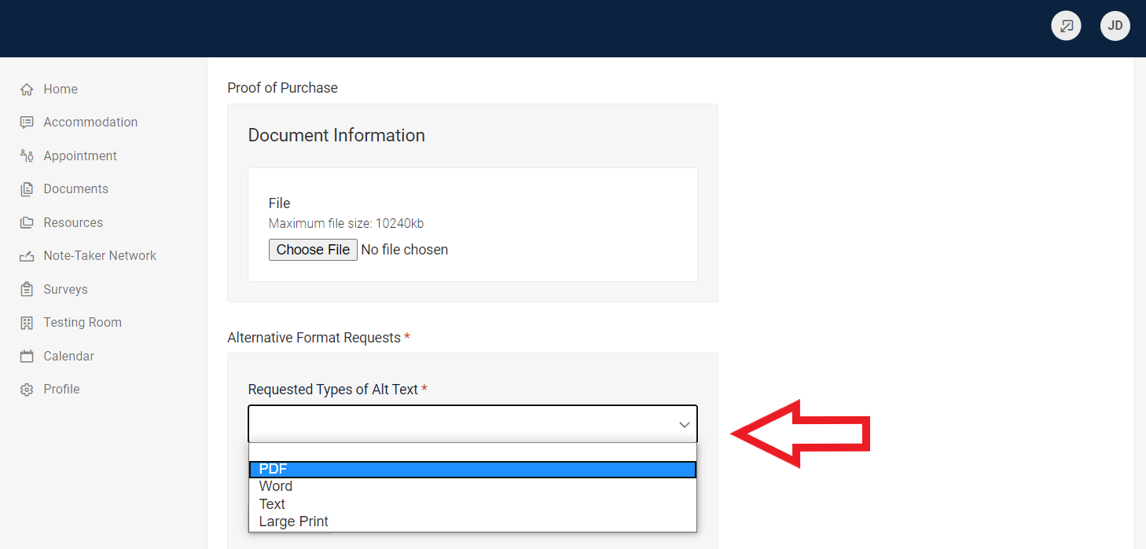

8. For requests where you have the article or reading and need it to be converted to an accessible format, you can upload the document to us. Click Add New.
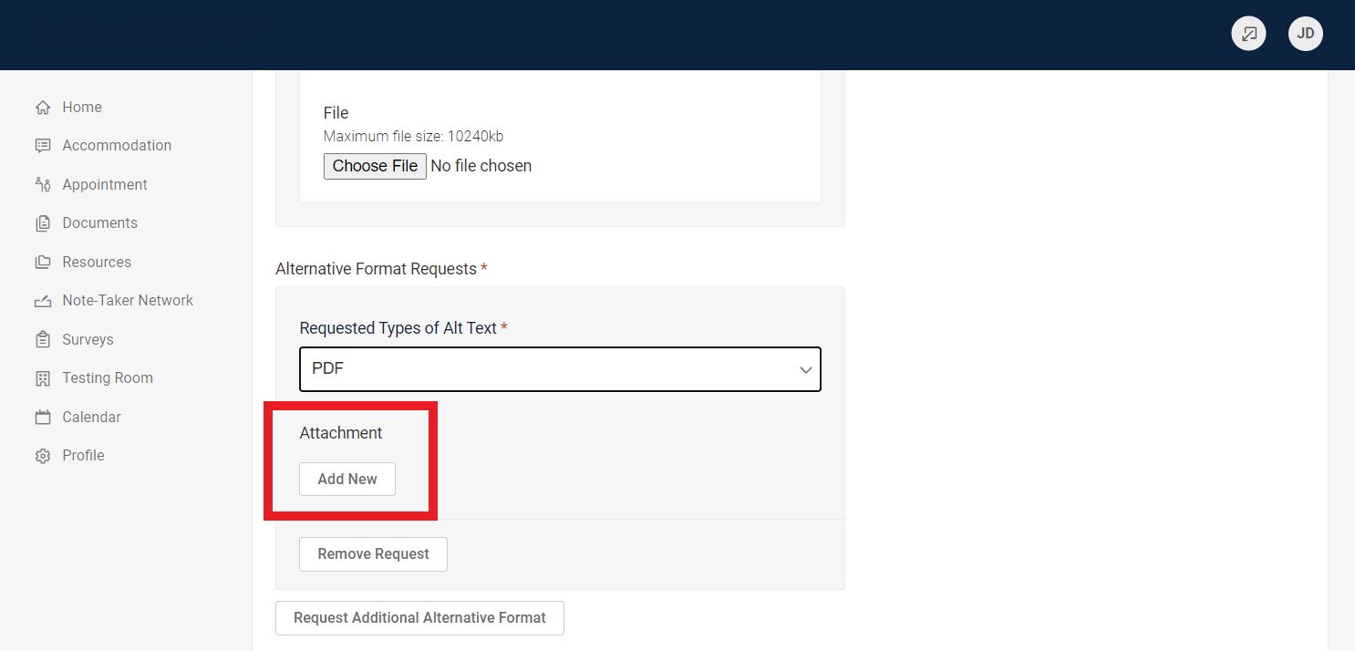

9. You can add any many documents as needed by clicking Request Additional Alternative Format button and following the same steps.
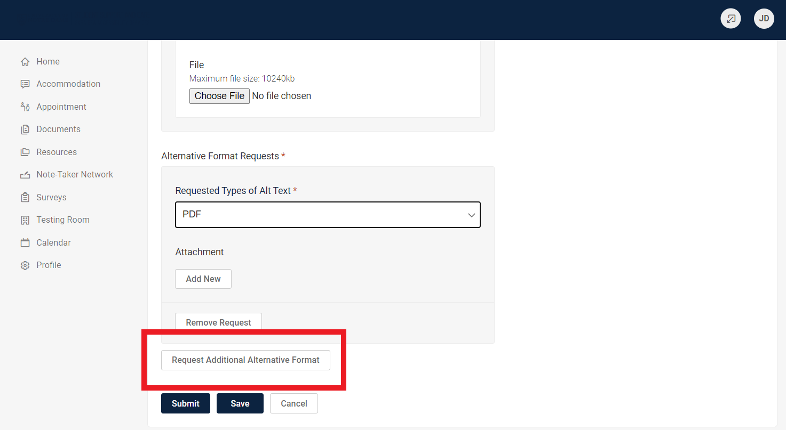

10. When you have added all your request, click Submit.
