Student AccessND Instructions
Current Students Requesting Renewal of Accommodations for a New Semester

- In InsideND, Search “AccessND” and click on the logo to navigate to your Student page.
- The first time you log in each semester, you will be prompted to sign an Acknowledgement Statement. Click “Respond” to do so.
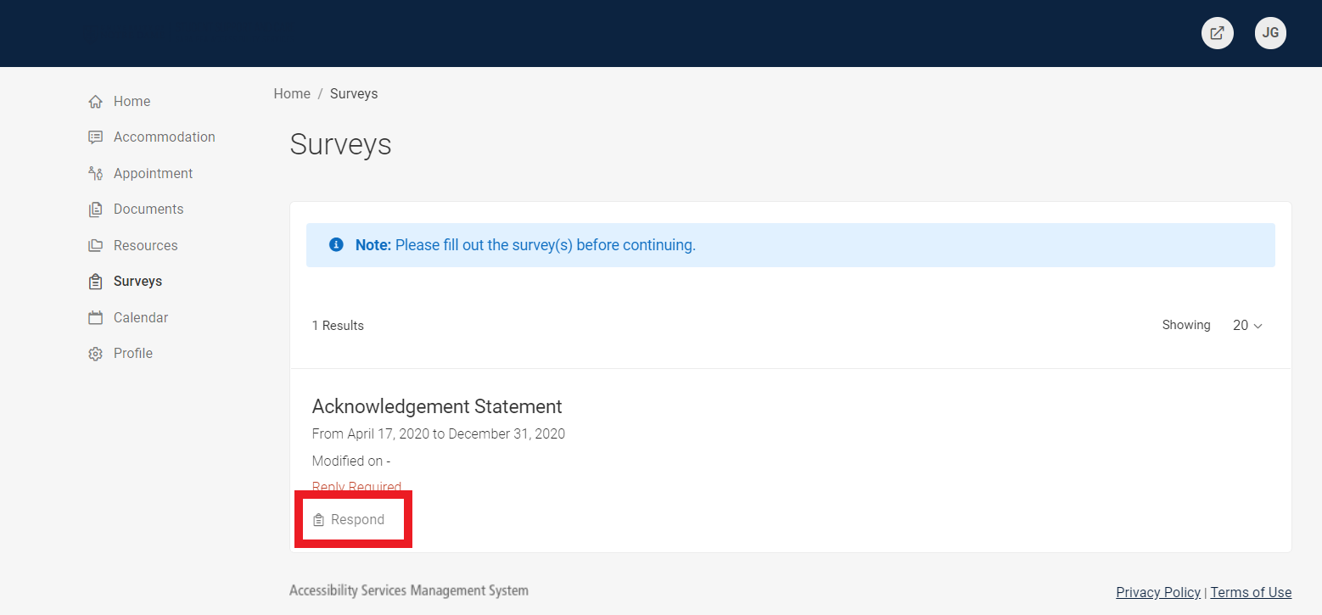

- Read the statement, type your name, and click “Submit.”
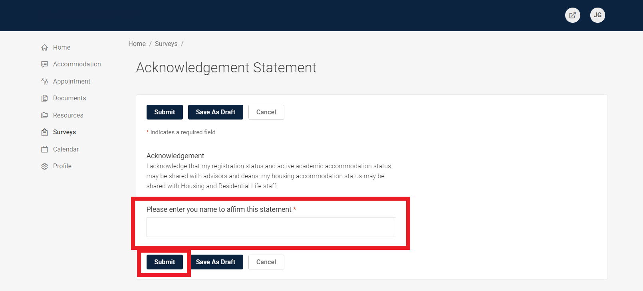
- You will then see your Student Home Page.
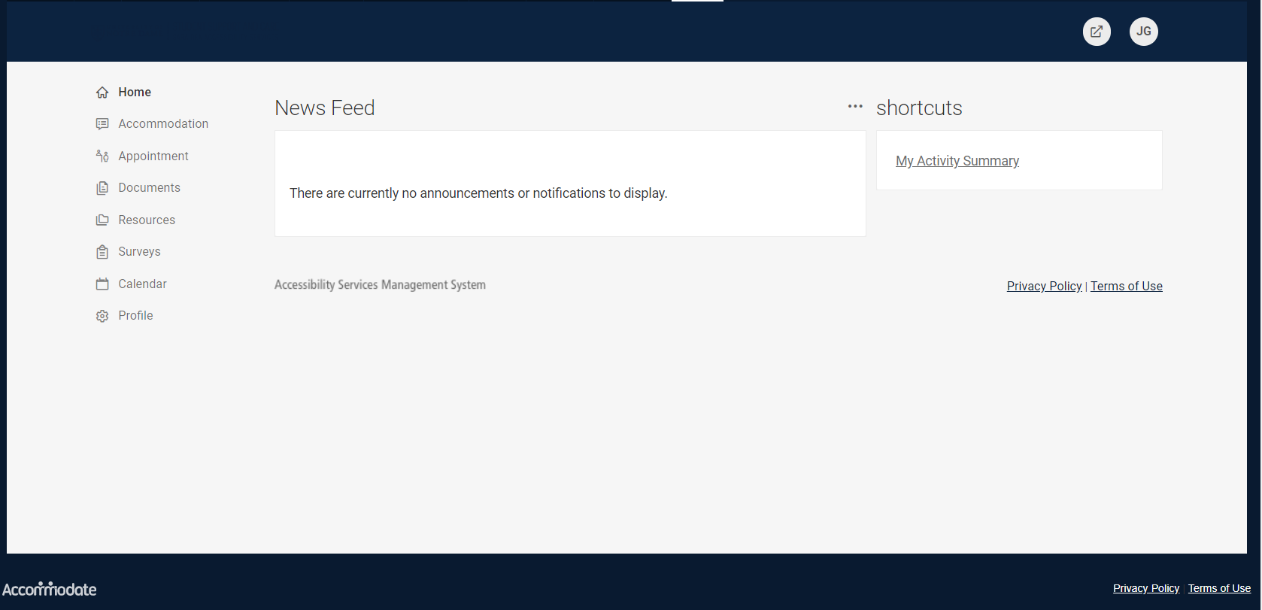

- Choose Accommodation from the Left Side Menu. Click on Semester Request from the options that appear beneath it.
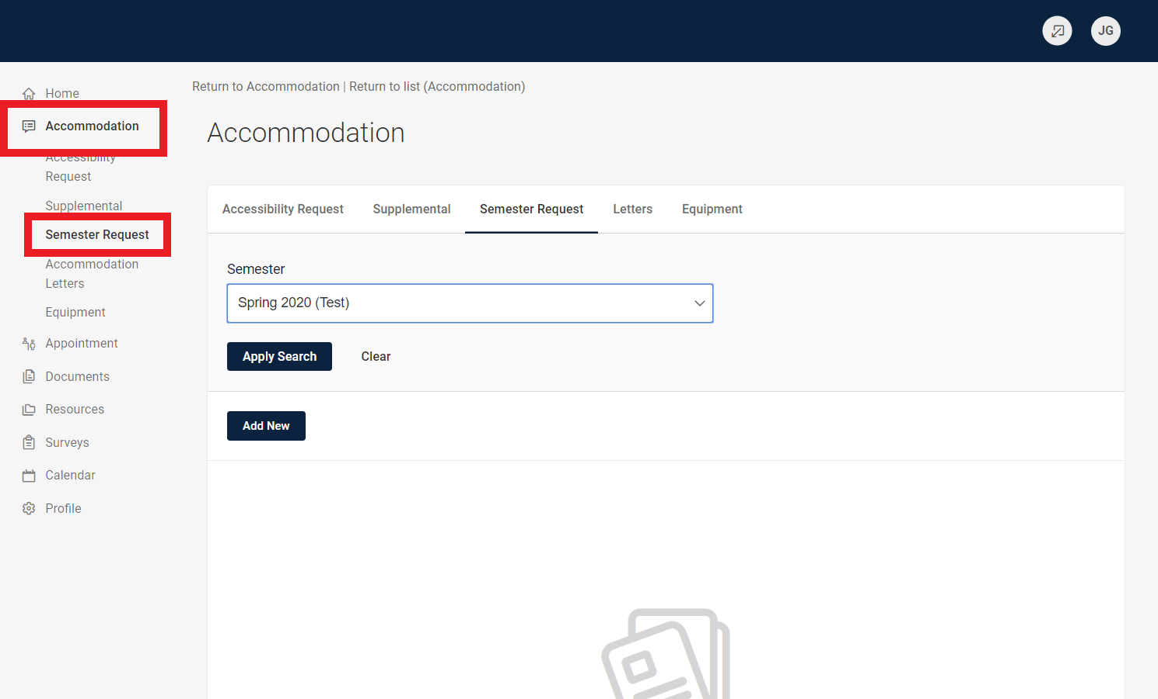
- Click Add New.
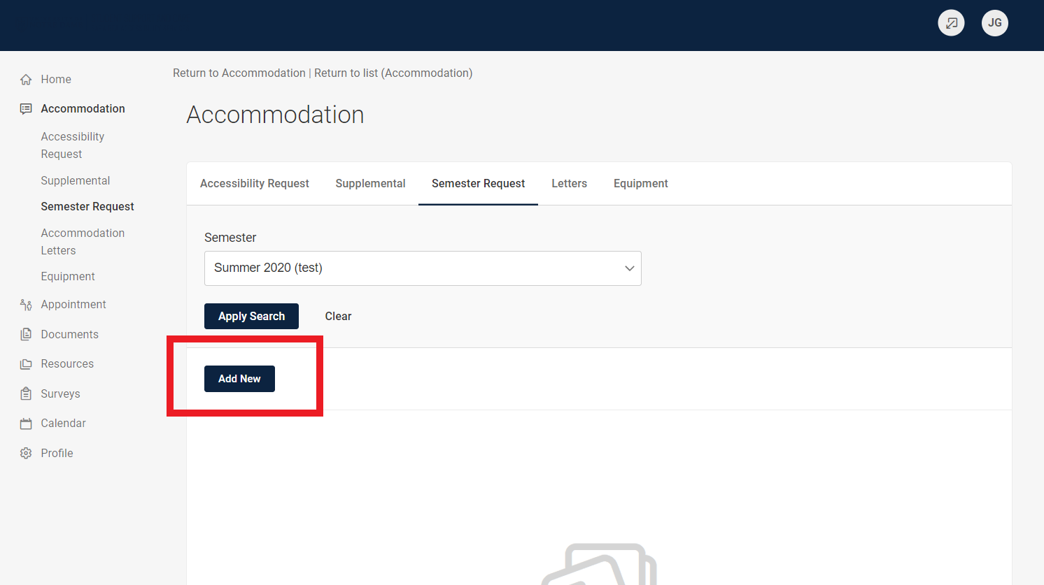
- In the blue box, you will see a list of all accommodations for which you have previously been approved. Under the Semester drop down menu, choose the semester in which you would like use your accommodations.
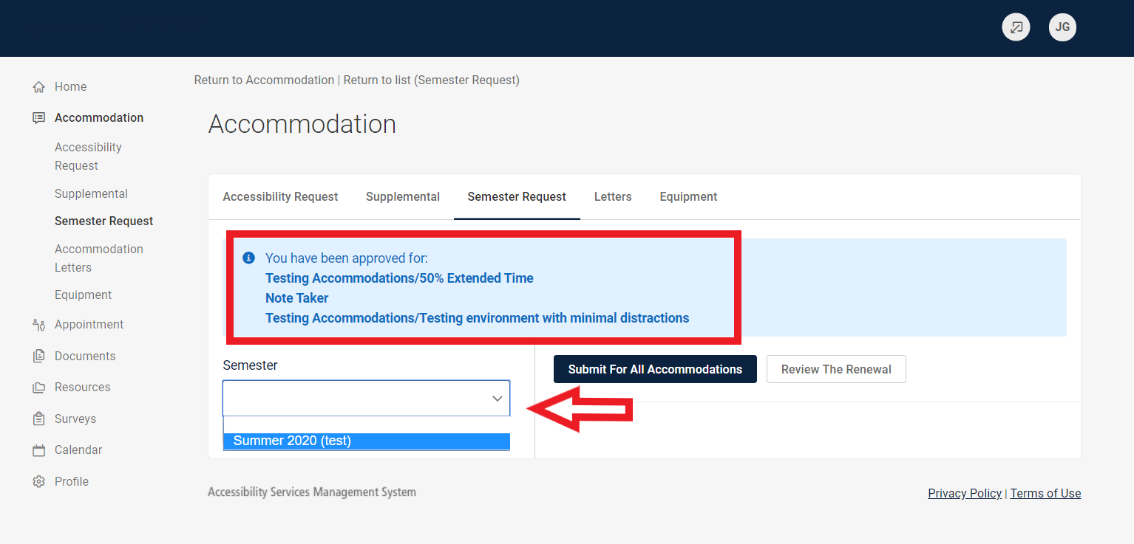
- Your classes for the selected semester will appear on the right-hand side. Choose Review the Renewal to determine which accommodations you need in each class.
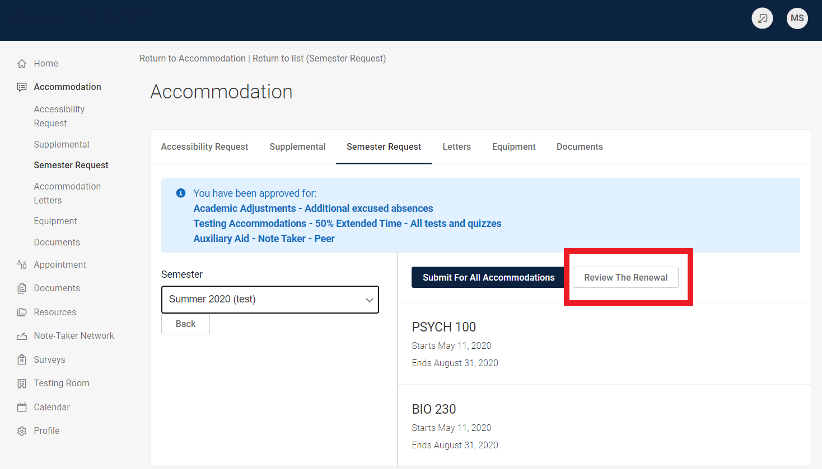
- You will see your first accommodation listed in the gray box. Below, check the class(es) that you will use the accommodation.
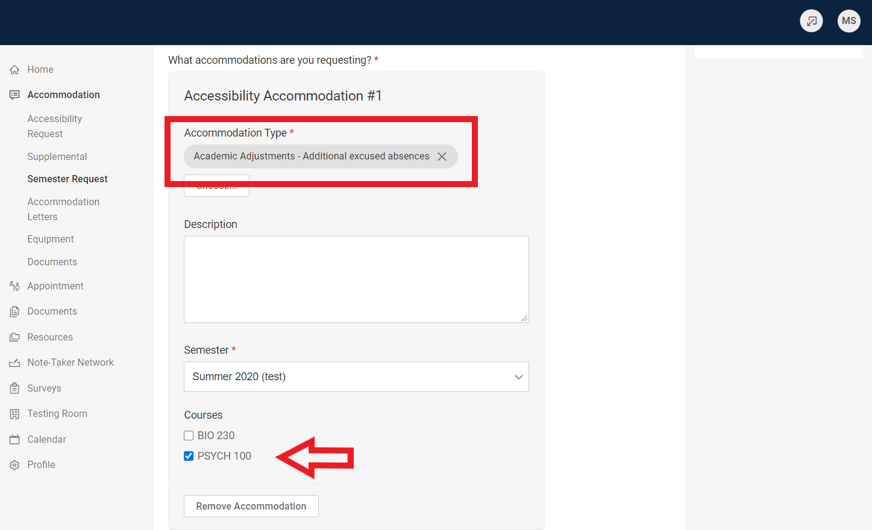

- If you have more than one accommodation, scroll down and repeat the process for each accommodation, choosing what class you need the accommodation.
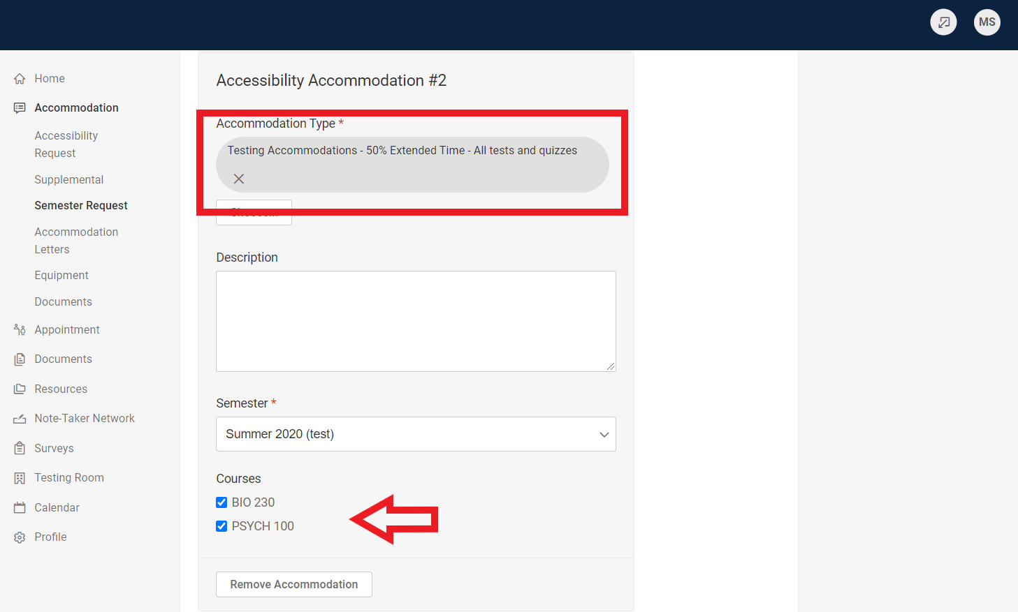

- At the bottom of the Review the Renewal page, Click “Submit”
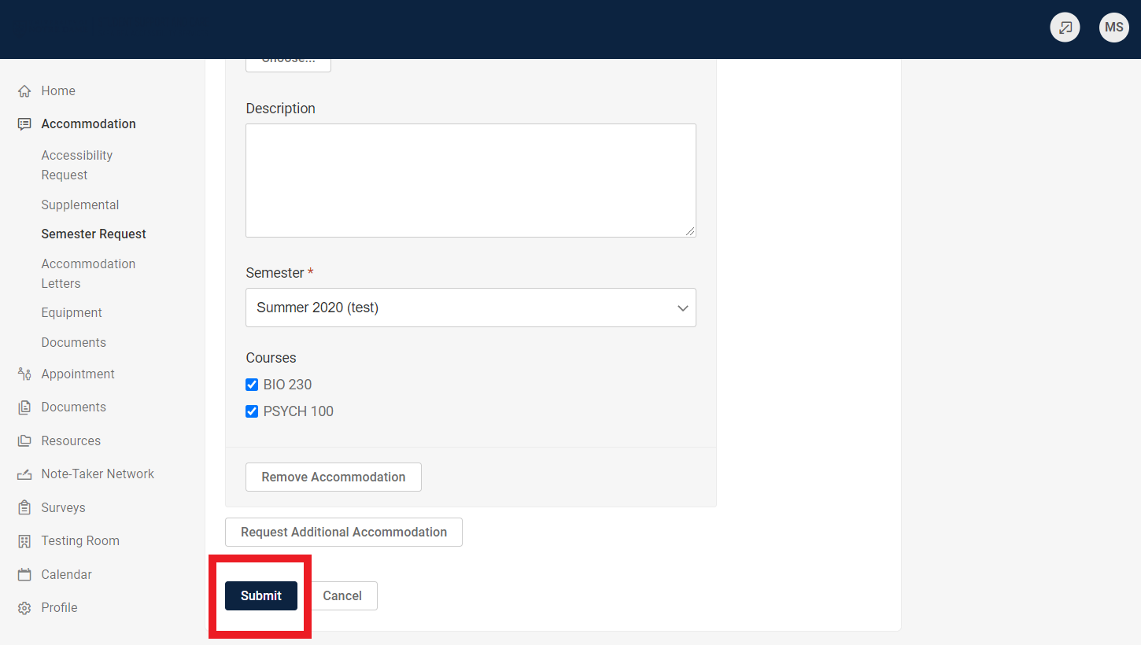

- Once you renew your accommodations, you will see a confirmation of the Accommodations along with the semester and courses. After the Sara Bea staff reviews the renewal, an accommodation letter will be sent to your instructors for their signature. If you requested Note-Taking or an Alternative Text, our office will begin working to fill that request.
